**SQL Project: RCB - IPL Strategy**

**Objective Questions**

1. List the different dtypes of columns in table “ball_by_ball” (using information schema)

**Answer:**

Different dtypes of columns in table “ball_by_ball” and their data types are shown below:

| **Column Name** | **Data Type** |
| --- | --- |
| Match_Id | int |
| Over_Id | int |
| Ball_Id | int |
| Innings_No | int |
| Team_Batting | int |
| Team_Bowling | int |
| Striker_Batting_Position | int |
| Striker | int |
| Non_Striker | int |
| Bowler | int |
| Runs_Scored | int |

**Conclusion:**

All columns in this table store numbers, which means they mostly contain IDs or counts like match ID, over number, runs, and players.

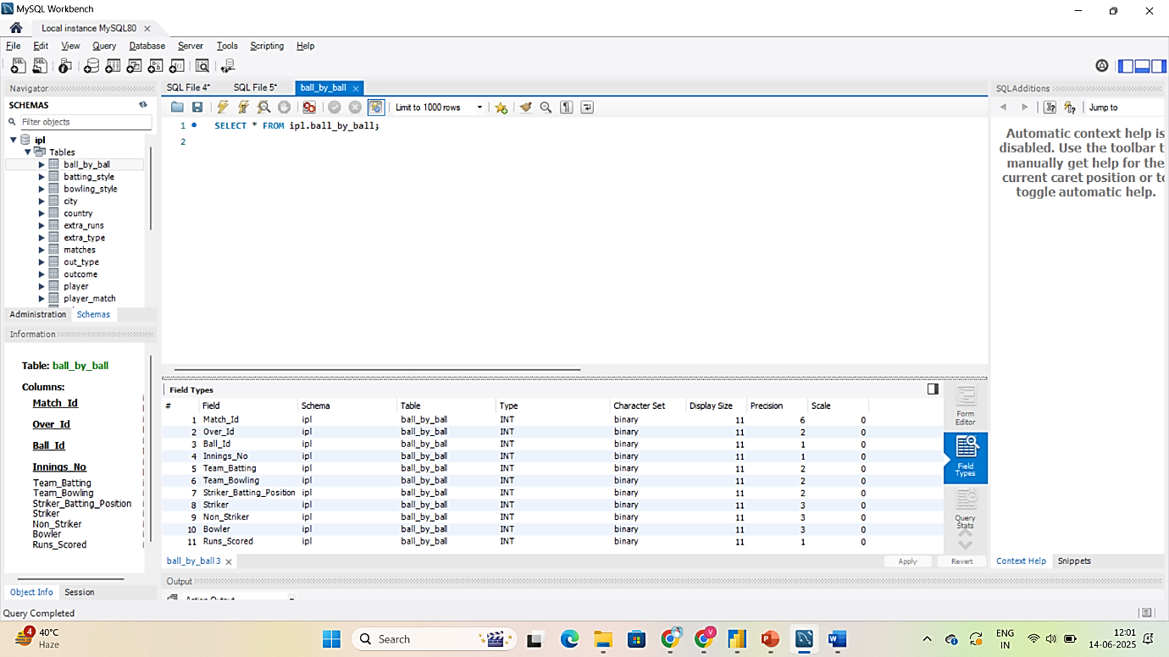

1. What is the total number of runs scored in 1st season by RCB (bonus: also include the extra runs using the extra runs table)

**Answer :**

To find out how many total runs RCB scored in the **1st IPL season (2008)**, I used the Ball_by_Ball, Matches, and Extra_Runs tables to calculate both:

* Runs scored off the bat
* Extra runs (like wides, no balls, byes)

I joined the tables on Match_Id, Over_Id, Ball_Id, and Innings_No, and filtered the data using:

* Season_Id = 1 → for Season 1
* Team_Batting = 2 → for RCB (Team ID 2)

**Final MySQL Query:**

SELECT

SUM(b.Runs_Scored + COALESCE(e.Extra_Runs,0))AS Total_Runs_With_Extras

FROM Ball_by_Ball b

JOIN Matches m ON b.Match_Id = m.Match_Id

LEFT JOIN Extra_Runs e

ON b.Match_Id = e.Match_Id

AND b.Over_Id = e.Over_Id

AND b.Ball_Id = e.Ball_Id

AND b.Innings_No = e.Innings_No

WHERE m.Season_Id = 1

AND b.Team_Batting = 2;

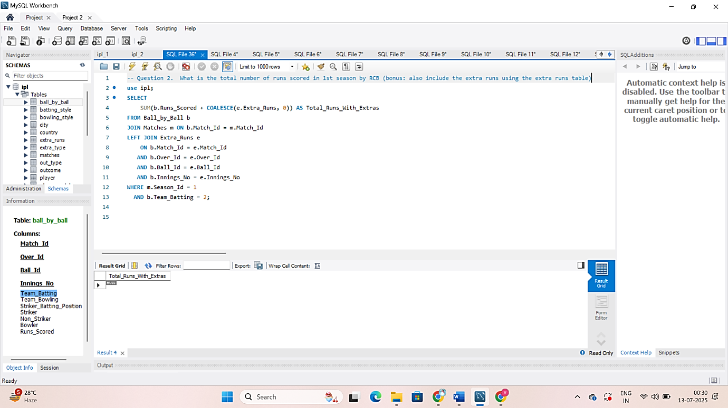

However, the output returned **NULL**, which means **no records matched these conditions**.

**Explanation:**

After checking the Matches table visually, I found that there were **no match entries for RCB (Team_Id = 2) in the 2008 season**. This could be due to:

* Missing match data for 2008
* Incomplete or partial database
* Data starting only from 2009 (Season 2 onwards)

**Conclusion:**

Based on the available data in the database, **Royal Challengers Bangalore (RCB) has no recorded matches in the 1st IPL season (2008)**.  
Therefore, their **total runs scored in that season (including extras) is considered 0** as per the current dataset.

1. How many players were more than the age of 25 during season 2014?

**Answer: 89**

**Step 1: Table Required**

| **Table** | **Purpose** |
| --- | --- |
| **Player** | Contains Player_Id and DOB (Date of Birth) |
| **Player_Match** | Tells us which players played in which matches |
| **Matches** | Tells us the season of each match |
| **Season** | Contains Season_Year to filter 2014 |
|  |  |

**Step 2: Logic**

* We only want players who played in 2014
* Calculate their age on a fixed date in 2014, e.g., '2014-01-01'
* Use TIMESTAMPDIFF(YEAR, DOB, '2014-01-01') > 25 to filter players older than 25
* Count the number of unique players

**Final Query for MySQL;**

SELECT

COUNT(DISTINCT p.Player_Id) AS Players_Above_25

FROM

Player p

JOIN

Player_Match pm ON p.Player_Id = pm.Player_Id

JOIN

Matches m ON pm.Match_Id = m.Match_Id

JOIN

Season s ON m.Season_Id = s.Season_Id

WHERE

s.Season_Year = 2014

AND TIMESTAMPDIFF(YEAR, p.DOB, '2014-01-01') > 25;

**Explanation:**

| **Line** | **Explanation** |
| --- | --- |
| **JOIN Player_Match** | Gets players who played matches |
| **JOIN Matches** | Links matches to get Season_Id |
| **JOIN Season** | Filters season year to 2014 |
| **TIMESTAMPDIFF(YEAR, p.DOB, '2014-01-01') > 25** | Checks if player was older than 25 in 2014 |
| **COUNT(DISTINCT ...)** | Ensures a player is only counted once |

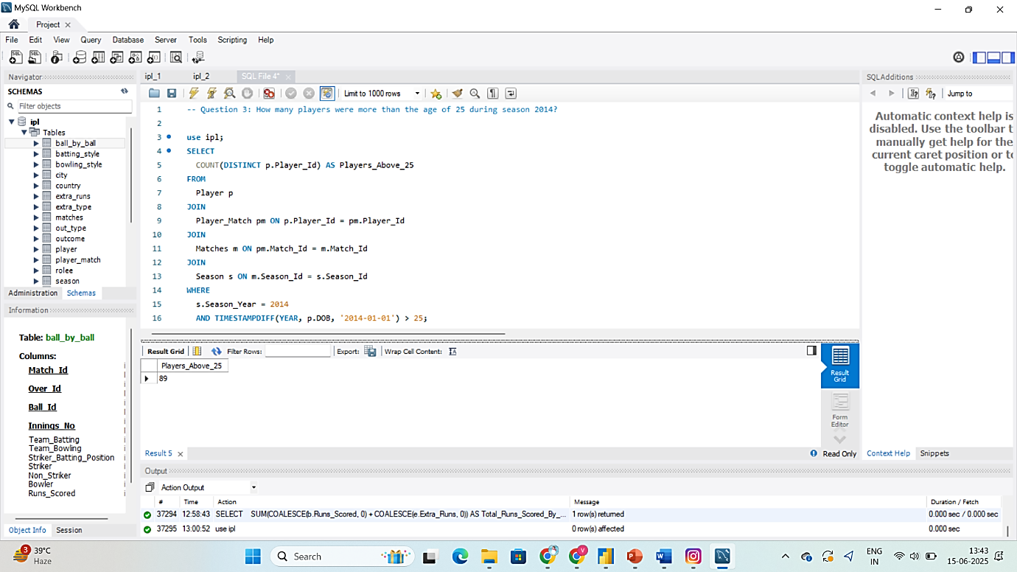

1. How many matches did RCB win in 2013?

Answer: **9**

**Tables involved:**

| **Table** | **Purpose** |
| --- | --- |
| Team | To get Team_Id of RCB |
| Matches | To get matches with Match_Winner and Season_Id |
| Season | To filter Season_Year = 2013 |

**Final MySQL Query:**

SELECT

COUNT(*) AS Matches_Won_By_RCB

FROM

Matches m

JOIN

Season s ON m.Season_Id = s.Season_Id

WHERE

s.Season_Year = 2013

AND m.Match_Winner = (

SELECT Team_Id

FROM Team

WHERE Team_Name = 'Royal Challengers Bangalore'

);

**Explanation**

| **Clause** | **Why it's used** |
| --- | --- |
| JOIN Season | To get season year from season ID |
| WHERE Season_Year = 2013 | Filters matches played in 2013 |
| Match_Winner = (SELECT...) | Filters only matches where RCB won |
| COUNT(*) | Counts the number of such matches |

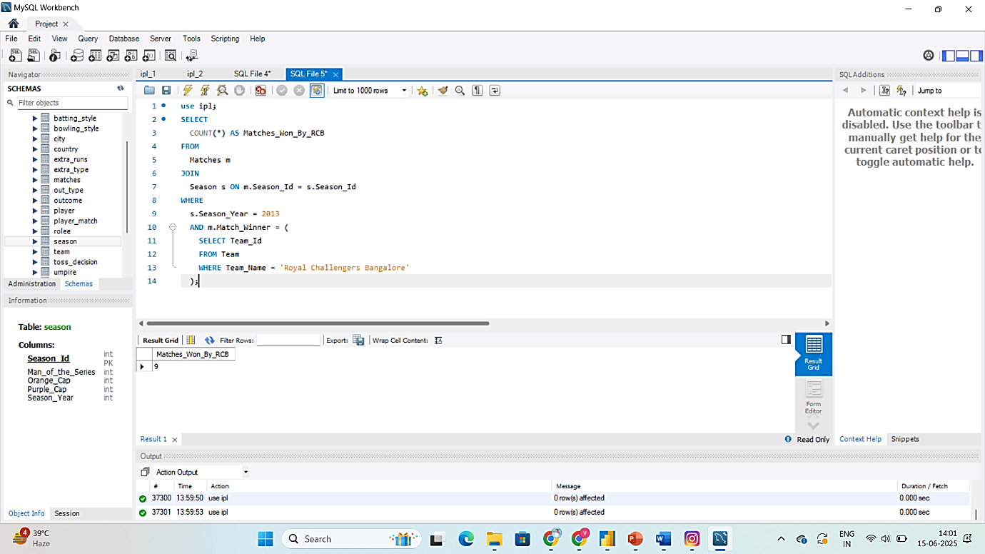

1. List the top 10 players according to their strike rate in the last 4 seasons.

**Answer**: Top 10 players according to their strike rate in the last 4 seasons are below:

|  |  |
| --- | --- |
| **RV Gomez** | 400.00 |
| **AN Ahmed** | 233.33 |
| **CR Brathwaite** | 207.50 |
| **PJ Sangwan** | 200.00 |
| **Bipul Sharma** | 192.59 |
| **KH Pandya** | 186.61 |
| **B Lee** | 175.00 |
| **M Morkel** | 173.68 |
| **SN Khan** | 171.84 |
| **BCJ Cutting** | 169.77 |

**Define Strike Rate:**

Strike Rate = (Total Runs Scored / Balls faced) * 100

**Tables Involved:**

| **Table** | **Purpose** |
| --- | --- |
| Ball_by_Ball | Contains Runs_Scored, Striker (Player_Id), and delivery data |
| Matches | Connects each ball to a match and season |
| Season | To filter the last 4 seasons using Season_Year |
| Player | To get player names |

**Final SQL Query:**

SELECT

p.Player_Name,

ROUND(SUM(b.Runs_Scored) * 100.0 / COUNT(b.Ball_Id), 2) AS Strike_Rate

FROM

Ball_by_Ball b

JOIN

Matches m ON b.Match_Id = m.Match_Id

JOIN

Season s ON m.Season_Id = s.Season_Id

JOIN

Player p ON b.Striker = p.Player_Id

WHERE

s.Season_Year >= (

SELECT MAX(Season_Year) - 3

FROM Season

)

GROUP BY

p.Player_Id

HAVING

COUNT(b.Ball_Id) >= 10 -- optional: avoid very low ball counts

ORDER BY

Strike_Rate DESC

LIMIT 10;

**Explanation:**

| **Clause** | **Reason** |
| --- | --- |
| s.Season_Year >= (SELECT MAX(Season_Year) - 3) | Filters last 4 seasons dynamically |
| SUM(Runs_Scored) | Total runs scored by each player |
| COUNT(Ball_Id) | Approximates balls faced (one row per ball per striker) |
| HAVING COUNT(Ball_Id) >= 10 | Removes players who faced very few balls |
| ORDER BY Strike_Rate DESC | Sorts highest strike rate first |
| LIMIT 10 | Gets top 10 players only |

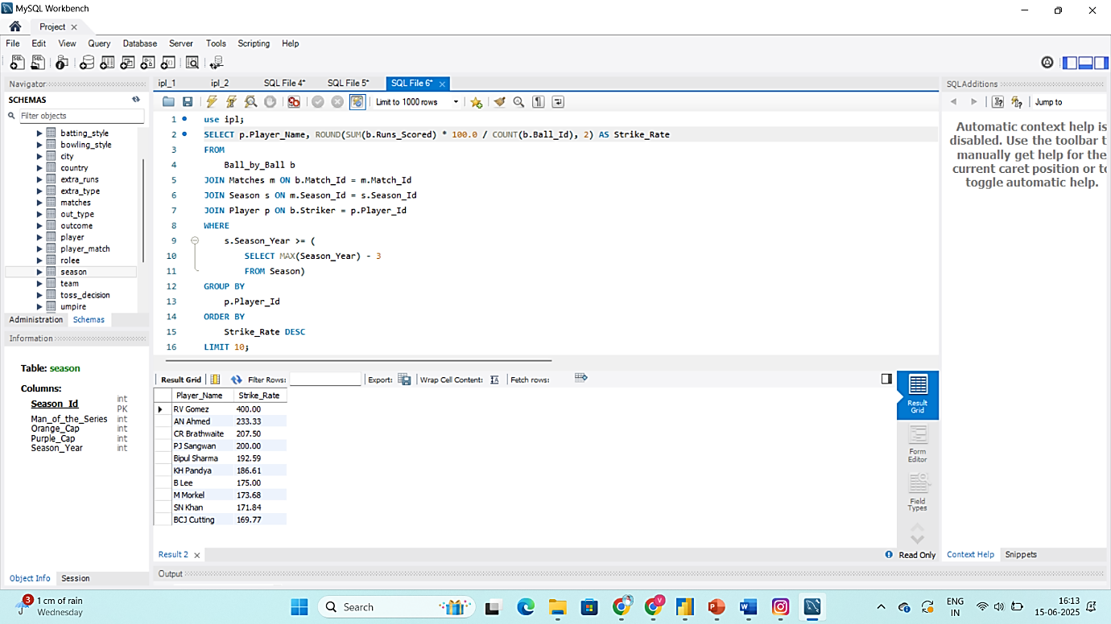

1. What are the average runs scored by each batsman considering all the seasons?

**Answers: Example Output (Limited)**

|  |  |  |  |
| --- | --- | --- | --- |
| **Player Name** | **Total Runs** | **Innings Played** | **Average Runs** |
| LMP Simmons | 942 | 22 | 42.82 |
| V Kohli | 2472 | 63 | 39.24 |
| DA Warner | 2348 | 62 | 37.87 |
| N Rana | 104 | 3 | 34.67 |
| MEK Hussey | 1019 | 30 | 33.97 |
| AB de Villiers | 1968 | 58 | 33.93 |
| AM Rahane | 1847 | 57 | 32.40 |
| CH Gayle | 1634 | 51 | 32.04 |

**Step 1: Formula Used:** We are calculating batting average, defined here as:

Average Runs= (Total Runs Scored​) / (Number of Innings Played)

We'll treat each **Distinct** combination of **Match_Id and Innings_No** where a player batted as an **innings played**.

**Step 2: Identify Tables Used:**

| **Table** | **Usage** |
| --- | --- |
| **Ball_by_Ball** | Contains Striker and Runs_Scored |
| **Player** | To get Player_Name |

(No need for Matches or Season in this case, since it's across all seasons)

**Step 3: Break Down the Query Using CTEs:**

We'll use two CTEs:

* First to calculate total runs per batsman
* Second to calculate total innings played per batsman;

**Final SQL Query:**

WITH player_runs AS (

SELECT

Striker AS Player_Id,

SUM(Runs_Scored) AS Total_Runs

FROM

Ball_by_Ball

GROUP BY

Striker

),

player_innings AS (

SELECT

Striker AS Player_Id,

COUNT(DISTINCT CONCAT(Match_Id, '-', Innings_No)) AS Innings_Played

FROM

Ball_by_Ball

GROUP BY

Striker

)

SELECT

p.Player_Name,

r.Total_Runs,

i.Innings_Played,

ROUND(r.Total_Runs * 1.0 / i.Innings_Played, 2) AS Avg_Runs

FROM

player_runs r

JOIN

player_innings i ON r.Player_Id = i.Player_Id

JOIN

Player p ON p.Player_Id = r.Player_Id

ORDER BY

Avg_Runs DESC;

**Explanation of Each Step:**

| **Step** | **Query Section** | **What It Does** |
| --- | --- | --- |
| 1 | player_runs CTE | Aggregates total runs per player from Ball_by_Ball |
| 2 | player_innings CTE | Counts distinct innings using CONCAT(Match_Id, '-', Innings_No) to uniquely identify each batting opportunity |
| 3 | JOINs | Combines total runs and innings using Player_Id, and fetches Player_Name from Player table |
| 4 | ROUND(...) | Calculates and formats the average to 2 decimal places |
| 5 | ORDER BY Avg_Runs DESC | Sorts players from highest to lowest average |

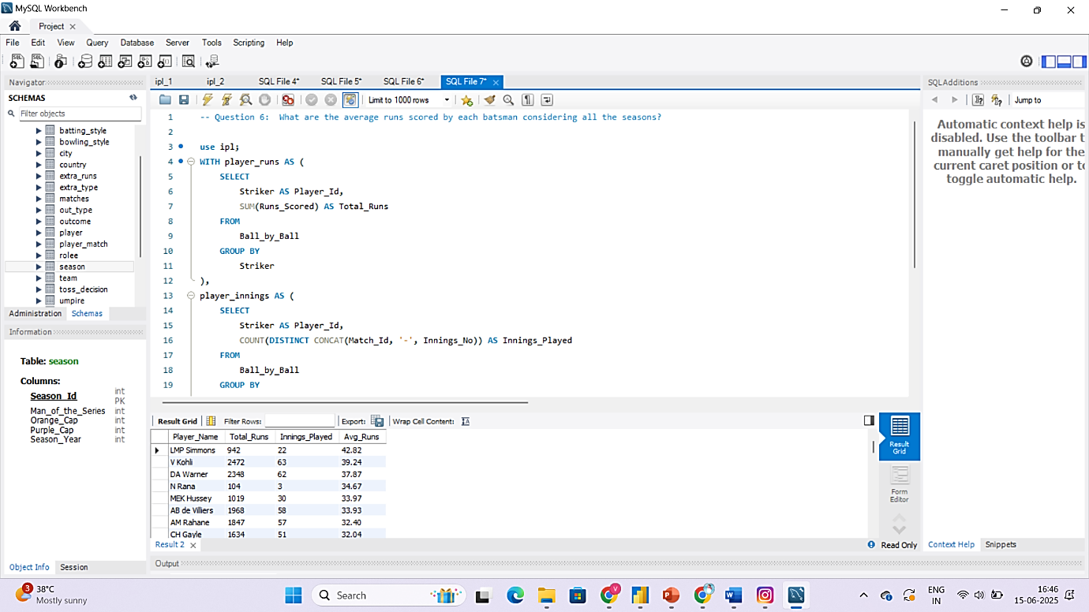

1. What are the average wickets taken by each bowler considering all the seasons?

**Answers: Example Output (Limited)**

|  |  |  |  |
| --- | --- | --- | --- |
| **Player Name** | **Total Wickets** | **Innings Bowled** | **Average Wickets** |
| A Zampa | 12 | 5 | 2.40 |
| Kuldeep Yadav | 7 | 3 | 2.33 |
| R McLaren | 4 | 2 | 2.00 |
| Harmeet Singh | 7 | 4 | 1.75 |
| DJ Bravo | 81 | 49 | 1.65 |
| SL Malinga | 66 | 42 | 1.57 |
| BE Hendricks | 11 | 7 | 1.57 |
| Karanveer Singh | 14 | 9 | 1.56 |
| Imran Tahir | 31 | 20 | 1.55 |

**Step 1: Formula Used:** We are calculating average wickets, defined here as:

Average Wickets = (Total Wickets Taken) / (Number of Innings Bowled)

**We will find**:

* Count total wickets per bowler (excluding extras like run outs if needed)
* Count how many innings they bowled in (Match_Id + Innings_No)
* Then calculate the average

**Tables Involved:**

| **Table** | **Purpose** |
| --- | --- |
| Wicket_Taken | Gives details of wickets (has Bowler_Id and Match_Id, etc.) |
| Player | For bowler names |
| Ball_by_Ball | To get innings each bowler bowled in (optional if needed) |

**Final SQL Query Using CTEs:**

WITH bowler_wickets AS (

SELECT

b.Bowler AS Player_Id,

COUNT(w.Player_Out) AS Total_Wickets

FROM

Ball_by_Ball b

JOIN

Wicket_Taken w ON b.Match_Id = w.Match_Id

AND b.Over_Id = w.Over_Id

AND b.Ball_Id = w.Ball_Id

AND b.Innings_No = w.Innings_No

GROUP BY

b.Bowler

),

bowler_innings AS (

SELECT

Bowler AS Player_Id,

COUNT(DISTINCT CONCAT(Match_Id, '-', Innings_No)) AS Innings_Bowled

FROM

Ball_by_Ball

GROUP BY

Bowler

)

SELECT

p.Player_Name,

w.Total_Wickets,

i.Innings_Bowled,

ROUND(w.Total_Wickets * 1.0 / i.Innings_Bowled, 2) AS Avg_Wickets

FROM

bowler_wickets w

JOIN

bowler_innings i ON w.Player_Id = i.Player_Id

JOIN

Player p ON p.Player_Id = w.Player_Id

ORDER BY

Avg_Wickets DESC;

**Explanation of Each Step:**

| **Step** | **Part** | **Description** |
| --- | --- | --- |
| 1 | bowler_wickets | Counts how many times each bowler took a wicket |
| 2 | bowler_innings | Counts in how many innings the bowler bowled |
| 3 | Final SELECT | Joins data and calculates average wickets per innings |
| 4 | ROUND(..., 2) | Formats the average to 2 decimal places |

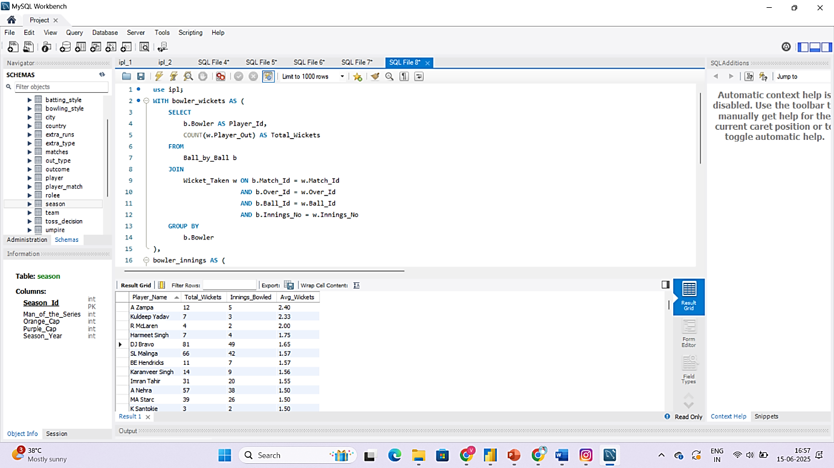

1. List all the players who have average runs scored greater than the overall average and who have taken wickets greater than the overall average.

**Answers: Example Output (Limited)**

|  |  |  |
| --- | --- | --- |
| **Player Name** | **Average runs** | **Total wickets taken** |
| JH Kallis | 21.00 | 23 |
| SR Watson | 23.91 | 54 |
| RA Jadeja | 13.40 | 56 |
| JA Morkel | 16.08 | 18 |
| MC Henriques | 18.37 | 37 |
| KA Pollard | 22.37 | 19 |
| STR Binny | 13.83 | 20 |
| Shakib Al Hasan | 17.23 | 25 |

We’ll solve this in three parts using **Common Table Expressions (CTEs):**

**Part 1: Calculate average runs per batsman**

From the Ball_by_Ball table.

**Part 2: Calculate total wickets per bowler**

From the Wicket_Taken + Ball_by_Ball tables.

**Part 3: Calculate overall averages for both**

**Final SQL Query:**

WITH player_runs AS (

SELECT

Striker AS Player_Id,

SUM(Runs_Scored) AS Total_Runs,

COUNT(DISTINCT CONCAT(Match_Id, '-', Innings_No)) AS Innings_Played

FROM

Ball_by_Ball

GROUP BY

Striker

),

player_avg_runs AS (

SELECT

Player_Id,

ROUND(Total_Runs * 1.0 / Innings_Played, 2) AS Avg_Runs

FROM

player_runs

WHERE Innings_Played > 0

),

overall_avg_runs AS (

SELECT

ROUND(AVG(Total_Runs * 1.0 / Innings_Played), 2) AS Overall_Avg_Runs

FROM

player_runs

WHERE Innings_Played > 0

),

player_wickets AS (

SELECT

b.Bowler AS Player_Id,

COUNT(w.Player_Out) AS Total_Wickets

FROM

Ball_by_Ball b

JOIN

Wicket_Taken w ON b.Match_Id = w.Match_Id

AND b.Over_Id = w.Over_Id

AND b.Ball_Id = w.Ball_Id

AND b.Innings_No = w.Innings_No

GROUP BY

b.Bowler

),

overall_avg_wickets AS (

SELECT

ROUND(AVG(Total_Wickets), 2) AS Overall_Wickets

FROM

player_wickets

)

SELECT

p.Player_Name,

r.Avg_Runs,

w.Total_Wickets

FROM

player_avg_runs r

JOIN

overall_avg_runs oar ON 1=1

JOIN

player_wickets w ON r.Player_Id = w.Player_Id

JOIN

overall_avg_wickets oaw ON 1=1

JOIN

Player p ON p.Player_Id = r.Player_Id

WHERE

r.Avg_Runs > oar.Overall_Avg_Runs

AND w.Total_Wickets > oaw.Overall_Wickets;

**What this query does:**

| **Section** | **Purpose** |
| --- | --- |
| player_avg_runs | Calculates average runs per batsman |
| overall_avg_runs | Gets the overall average run rate |
| player_wickets | Total wickets per bowler |
| overall_avg_wickets | Overall average wickets taken |
| Final SELECT | Combines players who exceed both averages and gets their name |

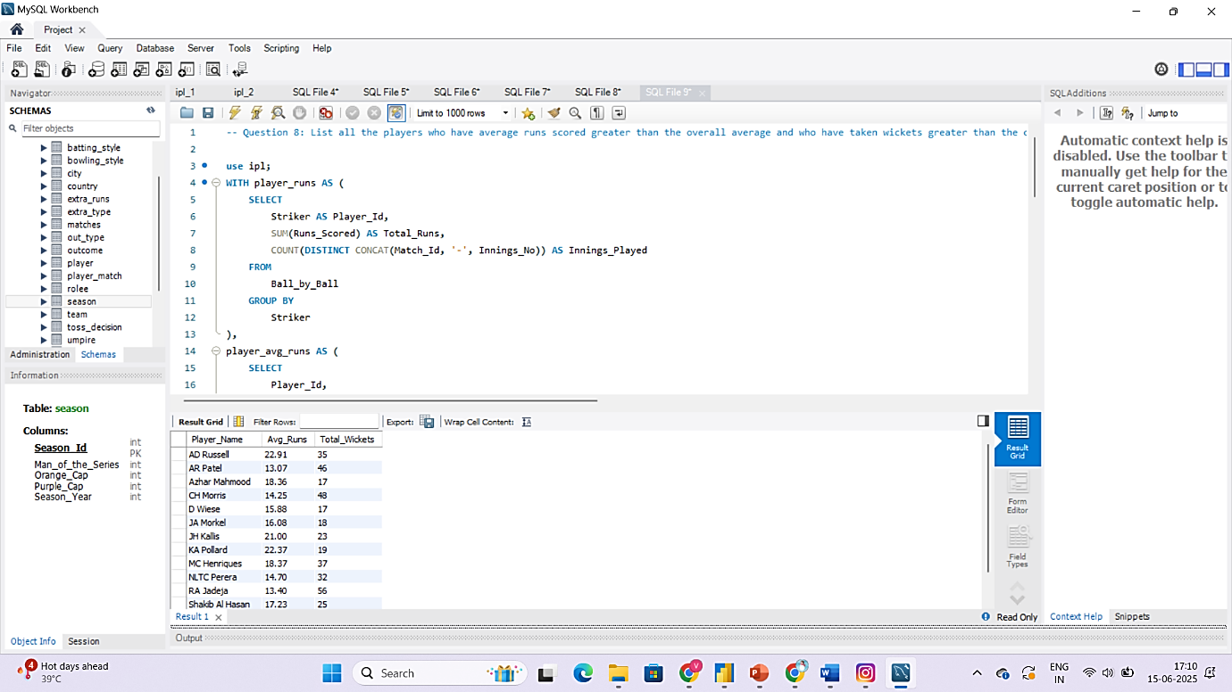

1. Create a table rcb_record table that shows the wins and losses of RCB in an individual venue.

**Answers: Example Output (Limited)**

|  |  |  |
| --- | --- | --- |
| **Venue Name** | **Wins** | **Losses** |
| M Chinnaswamy Stadium | 16 | 11 |
| Rajiv Gandhi International Stadium, Uppal | 1 | 3 |
| Wankhede Stadium | 1 | 3 |
| Feroz Shah Kotla | 2 | 0 |
| Maharashtra Cricket Association Stadium | 2 | 0 |
| Eden Gardens | 2 | 1 |
| JSCA International Stadium Complex | 1 | 2 |

**Table Required:**

| **Table** | **Columns Used** | **Purpose** |
| --- | --- | --- |
| Matches | Match_Winner, Team_1, Team_2, Venue_Id | To get match outcome and venue |
| Team | Team_Id, Team_Name | To get RCB's Team_Id |
| Venue | Venue_Id, Venue_Name | To show readable venue names |

**Step 1: Create the Table:**

CREATE TABLE rcb_record (

Venue_Name VARCHAR(100),

Wins INT DEFAULT 0,

Losses INT DEFAULT 0

);

**Step 2: Insert the Wins and Losses by Venue:**

SELECT

v.Venue_Name,

SUM(CASE WHEN m.Match_Winner = 2 THEN 1 ELSE 0 END) AS Wins,

SUM(CASE

WHEN (m.Match_Winner IS NOT NULL AND m.Match_Winner != 2 AND (m.Team_1 = 2 OR m.Team_2 = 2))

THEN 1

ELSE 0

END) AS Losses

FROM

Matches m

JOIN

Venue v ON m.Venue_Id = v.Venue_Id

WHERE

(m.Team_1 = 2 OR m.Team_2 = 2) -- RCB participated

GROUP BY

v.Venue_Name

order by wins desc, losses asc;

**Explanation:**

| **Clause** | **Description** |
| --- | --- |
| m.Match_Winner = 2 | Counts RCB wins |
| m.Match_Winner != 2 AND RCB played | Counts RCB losses |
| GROUP BY Venue_Name | To show result per venue |
| INSERT INTO rcb_record | Stores the result for future reference/reporting |

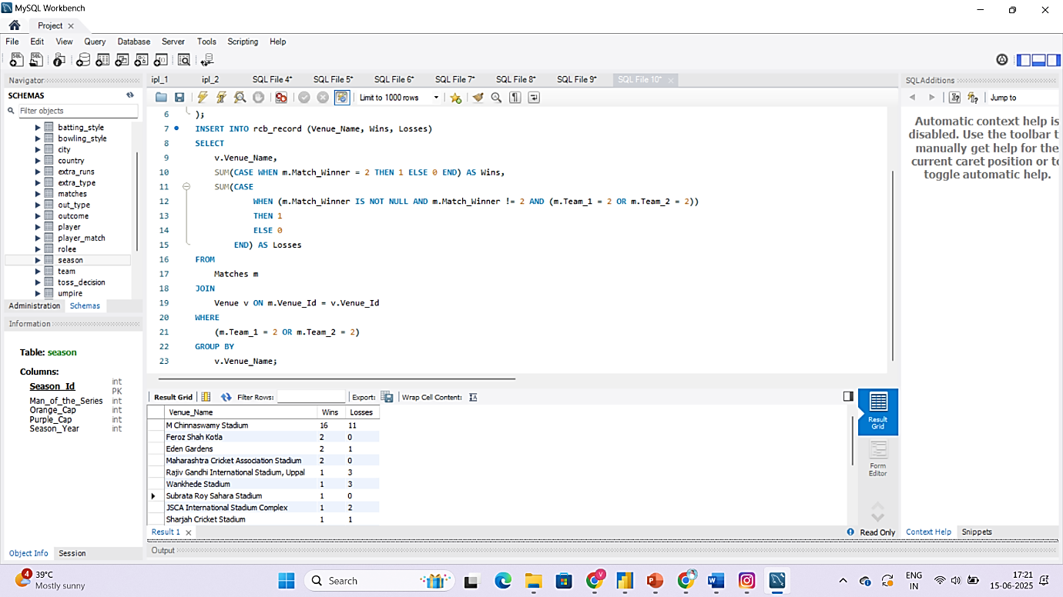

1. What is the impact of bowling style on wickets taken?

**Answers: Example Output (Limited)**

|  |  |
| --- | --- |
| **Bowling Style** | **Total Wickets** |
| Right-arm medium | 617 |
| Right-arm fast-medium | 382 |
| Right-arm medium-fast | 343 |
| Right-arm off break | 290 |
| Slow left-arm orthodox | 283 |

**Objective:**

Compare **total wickets taken by bowlers grouped by bowling style** across all matches and show the total number of wickets taken, grouped by bowling style.

**Table Involved:**

| **Table** | **Columns Used** | **Purpose** |
| --- | --- | --- |
| Player | Player_Id, Bowling_skill | To identify each bowler's style |
| Bowling_Style | Bowling_Id, Bowling_skill | Describes each style (e.g., off-spin, leg-break) |
| Ball_by_Ball | Bowler | Who bowled each delivery |
| Wicket_Taken | Match_Id, Over_Id, Ball_Id | Join with Ball_by_Ball to know when a wicket was taken |

**SQL Query:**

SELECT

bs.Bowling_skill AS Bowling_Style,

COUNT(w.Player_Out) AS Total_Wickets

FROM

Wicket_Taken w

JOIN

Ball_by_Ball b ON w.Match_Id = b.Match_Id

AND w.Over_Id = b.Over_Id

AND w.Ball_Id = b.Ball_Id

AND w.Innings_No = b.Innings_No

JOIN

Player p ON b.Bowler = p.Player_Id

JOIN

Bowling_Style bs ON p.Bowling_skill = bs.Bowling_Id

GROUP BY

bs.Bowling_skill

ORDER BY

Total_Wickets DESC;

**Explanation:**

| **Part** | **Why It’s Used** |
| --- | --- |
| Wicket_Taken + Ball_by_Ball | Links every dismissal to the delivery it happened |
| JOIN Player | Identifies who the bowler is |
| JOIN Bowling_Style | Gives the name of the bowling style (based on your mapping) |
| GROUP BY bs.Bowling_skill | Groups wickets by style |
| COUNT(w.Player_Out) | Counts how many wickets were taken by each style |

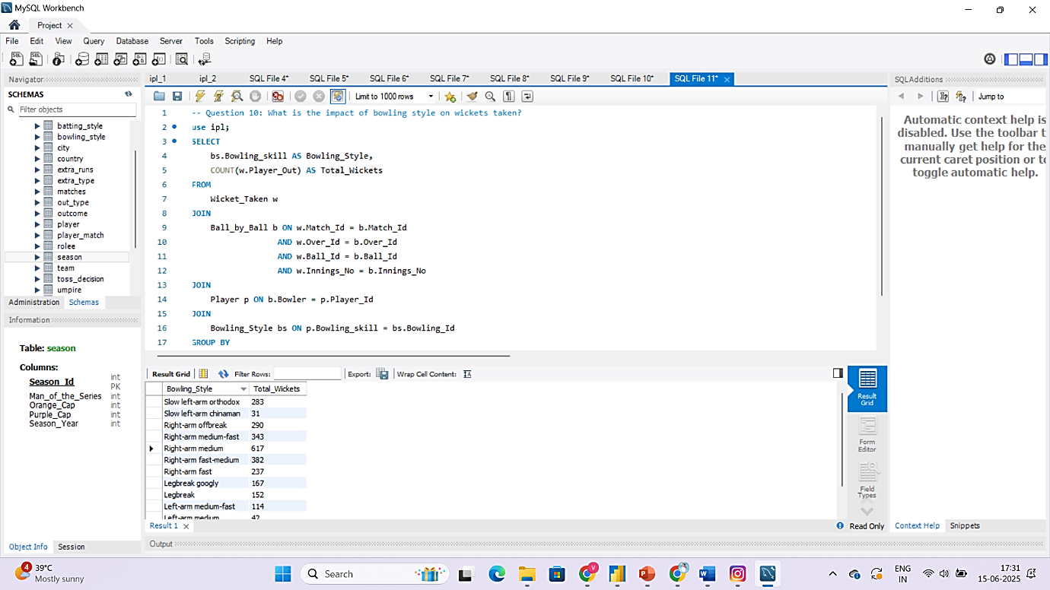

1. Write the SQL query to provide a status of whether the performance of the team is better than the previous year's performance on the basis of the number of runs scored by the team in the season and the number of wickets taken

**Answers: Example Output (Limited)**

|  |  |  |  |  |  |  |
| --- | --- | --- | --- | --- | --- | --- |
| **Team Name** | **Season Year** | **Total Runs** | **Total wickets** | **Previous Total Runs** | **Previous Total wickets** | **Performance status** |
| Chennai Super Kings | 2014 | 2519 | 98 | 2671 | 123 | Declined |
| Chennai Super Kings | 2015 | 2564 | 113 | 2519 | 98 | Improved |
| Delhi Daredevils | 2014 | 1978 | 60 | 2114 | 76 | Declined |
| Delhi Daredevils | 2015 | 2061 | 74 | 1978 | 60 | Improved |
| Delhi Daredevils | 2016 | 1995 | 77 | 2061 | 74 | Same |
| Kings XI Punjab | 2014 | 2824 | 113 | 2312 | 82 | Improved |
| Kings XI Punjab | 2015 | 1902 | 72 | 2824 | 113 | Declined |

**Objective:**

For each team and each season, check whether their performance **improved compared to the previous season**, based on:

* **Total Runs Scored** (by the team)
* **Total Wickets Taken** (by bowlers from the team)

**Performance status** will be like: 'Improved', 'Declined', or 'Same'.

**Need:**

| **Metric** | **Table** |
| --- | --- |
| Total runs scored | Ball_by_Ball, Matches, Season |
| Wickets taken | Wicket_Taken, Ball_by_Ball, Matches, Season |
| Team info | Team |

**SQL Query:**

WITH team_runs AS (

SELECT

m.Season_Id,

b.Team_Batting AS Team_Id,

SUM(b.Runs_Scored) AS Total_Runs

FROM

Ball_by_Ball b

JOIN

Matches m ON b.Match_Id = m.Match_Id

GROUP BY

m.Season_Id, b.Team_Batting

),

team_wickets AS (

SELECT

m.Season_Id,

b.Team_Bowling AS Team_Id,

COUNT(w.Player_Out) AS Total_Wickets

FROM

Ball_by_Ball b

JOIN

Matches m ON b.Match_Id = m.Match_Id

JOIN

Wicket_Taken w ON b.Match_Id = w.Match_Id

AND b.Over_Id = w.Over_Id

AND b.Ball_Id = w.Ball_Id

AND b.Innings_No = w.Innings_No

GROUP BY

m.Season_Id, b.Team_Bowling

),

combined AS (

SELECT

r.Season_Id,

r.Team_Id,

r.Total_Runs,

w.Total_Wickets

FROM

team_runs r

JOIN

team_wickets w ON r.Season_Id = w.Season_Id AND r.Team_Id = w.Team_Id

),

with_previous AS (

SELECT

c.*,

s.Season_Year,

LAG(c.Total_Runs) OVER (PARTITION BY c.Team_Id ORDER BY s.Season_Year) AS Prev_Total_Runs,

LAG(c.Total_Wickets) OVER (PARTITION BY c.Team_Id ORDER BY s.Season_Year) AS Prev_Total_Wickets

FROM

combined c

JOIN

Season s ON c.Season_Id = s.Season_Id

)

SELECT

t.Team_Name,

wp.Season_Year,

wp.Total_Runs,

wp.Total_Wickets,

wp.Prev_Total_Runs,

wp.Prev_Total_Wickets,

CASE

WHEN wp.Total_Runs > wp.Prev_Total_Runs AND wp.Total_Wickets > wp.Prev_Total_Wickets THEN 'Improved'

WHEN wp.Total_Runs < wp.Prev_Total_Runs AND wp.Total_Wickets < wp.Prev_Total_Wickets THEN 'Declined'

ELSE 'Same'

END AS Performance_Status

FROM

with_previous wp

JOIN

Team t ON wp.Team_Id = t.Team_Id

WHERE

wp.Prev_Total_Runs IS NOT NULL AND wp.Prev_Total_Wickets IS NOT NULL

ORDER BY

t.Team_Name, wp.Season_Year;

**Explanation:**

| **Step** | **What it does** |
| --- | --- |
| team_runs | Calculates total runs by each team per season |
| team_wickets | Calculates total wickets taken by each team per season |
| combined | Merges runs and wickets by team + season |
| with_previous | Uses LAG() to bring previous season’s runs & wickets |
| CASE | Compares current vs previous and gives status: 'Improved', 'Declined', or 'Same' |

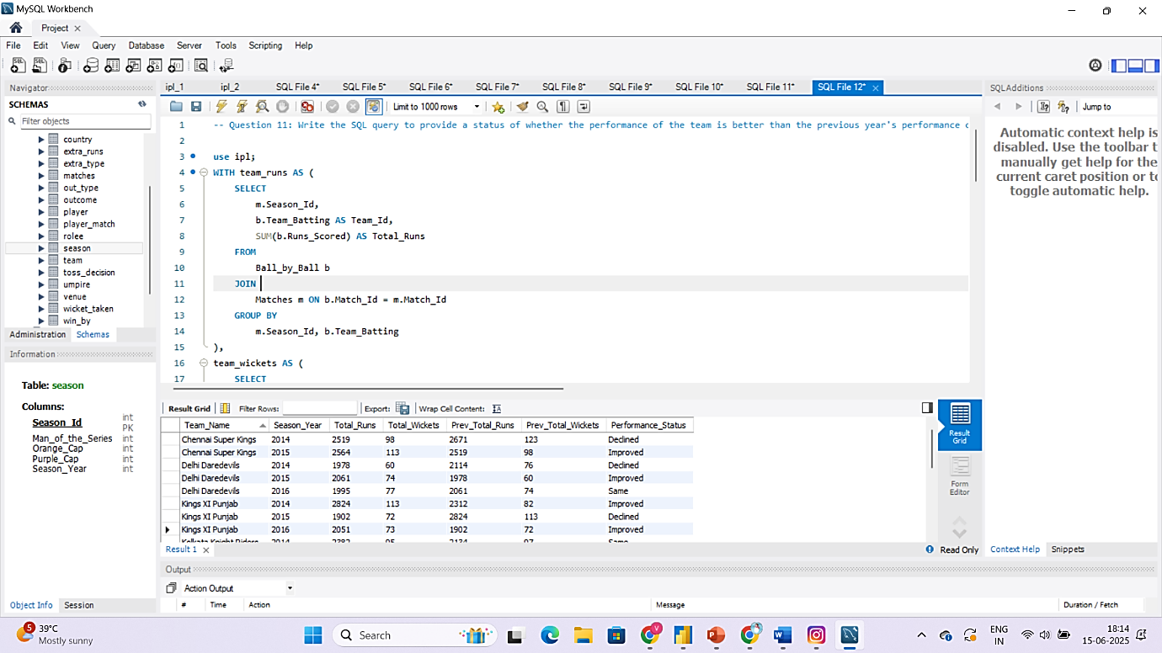

1. Can you derive more KPIs for the team strategy?

**Answer:**

**Top 5 KPIs for Team Strategy (with Formula):**

I derived the following 5 KPIs from the dataset to help analyse team performance and strategy. These KPIs are calculated using the data available:

**1. Win Percentage:**

**Formula:**

**(Number of Matches Won/Number of Matches Played​) ×100**

**Tables & Columns Used:**

Matches table:

* **Match_Winner** – to identify which team won
* **Team_1**, **Team_2** – to count total matches a team played

***This helps evaluate a team's overall success rate.***

**2. Average Runs per Match:**

**Formula:**

**(Total Runs Scored​ / Total Matches Played​)**

**Tables & Columns Used:**

**Ball_by_Ball** table**:**

* ***Runs_Scored*** – the runs scored per ball
* ***Team_Batting*** – which team scored the run

**Matches** table:

* ***Match_Id*** – to count unique matches per team

***Useful for understanding the team's scoring consistency****.*

**3. Average Wickets per Match:**

**Formula:**

**(Total Wickets Taken​​ / Total Matches Played​)**

**Tables & Columns Used:**

**Wicket_Taken** table**:**

* ***Player_Out*** – identifies a wicket taken

**Ball_by_Ball** table**:**

* ***Team_Bowling* –** to know which team took the wicket

**Matches** table**:**

* ***Match_Id* –** to group wickets match-wise

***This shows the bowling strength of a team***

**4. Run Rate:**

**Formula:**

**(Total Runs Scored​​​ / Total Overs Faced​)**

**Tables & Columns Used:**

**Ball_by_Ball table:**

* + - **Runs_Scored –** for total runs
    - **Over_Id –** to calculate total overs
    - **Team_Batting –** to group by team

***Helps understand how quickly a team scores runs.***

**5. Toss Impact KPI:**

**Formula:**

**Win % After Toss Decision (Bat/Field):**

**(Matches Won After Toss Decision / Matches with That Toss Decision) * 100**

*Understand if choosing to bat or field first affects performance*.

**Tables & Columns Used:**

**Matches** table**:**

* **Toss_Winner –** to identify which team won the toss
* **Toss_Decide –** to check if the team chose to bat or field
* **Match_Winner –** to verify if the toss-winning team also won **the match**

**Team** table**:**

* **Team_Id, Team_Name –** to display readable team names in the output

***Helps evaluate whether teams make the right decision after winning the toss and how it affects their chances of winning.***

1. Using SQL, write a query to find out the average wickets taken by each bowler in each venue. Also, rank the gender according to the average value.

**Answers: Example Output (Limited)**

|  |  |  |  |  |  |
| --- | --- | --- | --- | --- | --- |
| **Venue Name** | **Player Name** | **Total Wickets** | **Matches Played** | **Average Wickets** | **Rank** |
| Dr. Y.S. Rajasekhara Reddy ACA-VDCA Cricket Stadium | A Ashish Reddy | 1 | 2 | 0.50 | 34 |
| Eden Gardens | A Ashish Reddy | 1 | 1 | 1.00 | 29 |
| M Chinnaswamy Stadium | A Ashish Reddy | 1 | 3 | 0.33 | 79 |
| Rajiv Gandhi International Stadium, Uppal | A Ashish Reddy | 5 | 4 | 1.25 | 30 |
| MA Chidambaram Stadium, Chepauk | A Chandila | 1 | 1 | 1.00 | 26 |
| Punjab Cricket Association Stadium, Mohali | A Chandila | 1 | 1 | 1.00 | 25 |
| Sawai Mansingh Stadiumss | A Chandila | 4 | 5 | 0.80 | 33 |

**Objective :**

To understand the bowling performance across different venues, I calculated the **average wickets taken by each bowler at each venue**. Then, I ranked the bowlers within each venue based on their average wickets.

**Working :**

* First, I counted how many wickets each bowler took at each venue by using the **Wicket_Taken** and **Ball_by_Ball** tables.
* Then, I calculated the number of matches that bowler played at that venue using the **Matches** table.

I used the formula:

**Average Wickets = (Total Wickets​ / Matches Played at that Venue)**

* Finally, I ranked the bowlers **within each venue** based on their average using the **RANK()** function.

**SQL Query:**

WITH bowler_venue_wickets AS (

SELECT

b.Bowler AS Player_Id,

m.Venue_Id,

COUNT(w.Player_Out) AS Total_Wickets

FROM

Ball_by_Ball b

JOIN

Wicket_Taken w ON b.Match_Id = w.Match_Id

AND b.Over_Id = w.Over_Id

AND b.Ball_Id = w.Ball_Id

AND b.Innings_No = w.Innings_No

JOIN

Matches m ON b.Match_Id = m.Match_Id

GROUP BY

b.Bowler, m.Venue_Id

),

venue_avg_wickets AS (

SELECT

v.Venue_Name,

p.Player_Name,

w.Total_Wickets,

COUNT(DISTINCT b.Match_Id) AS Matches_Played,

ROUND(w.Total_Wickets * 1.0 / COUNT(DISTINCT b.Match_Id), 2) AS Avg_Wickets

FROM

bowler_venue_wickets w

JOIN

Venue v ON w.Venue_Id = v.Venue_Id

JOIN

Player p ON w.Player_Id = p.Player_Id

JOIN

Ball_by_Ball b ON b.Bowler = w.Player_Id

WHERE

b.Match_Id IN (SELECT Match_Id FROM Matches WHERE Venue_Id = w.Venue_Id)

GROUP BY

v.Venue_Name, p.Player_Name, w.Total_Wickets

)

SELECT

Venue_Name,

Player_Name,

Total_Wickets,

Matches_Played,

Avg_Wickets,

RANK() OVER (PARTITION BY Venue_Name ORDER BY Avg_Wickets DESC) AS Rank_in_Venue

FROM

venue_avg_wickets

ORDER BY

Venue_Name, Rank_in_Venue;

**Explanation :**

| **Step** | **What it Does** |
| --- | --- |
| bowler_venue_wickets | Counts the **total number of wickets** taken by each bowler at each venue. |
| venue_avg_wickets | Calculates how many **matches the bowler played at each venue** and computes their **average wickets per match**. |
| RANK() OVER (...) | Ranks the bowlers **within each venue** based on their **average wickets**, in descending order. |

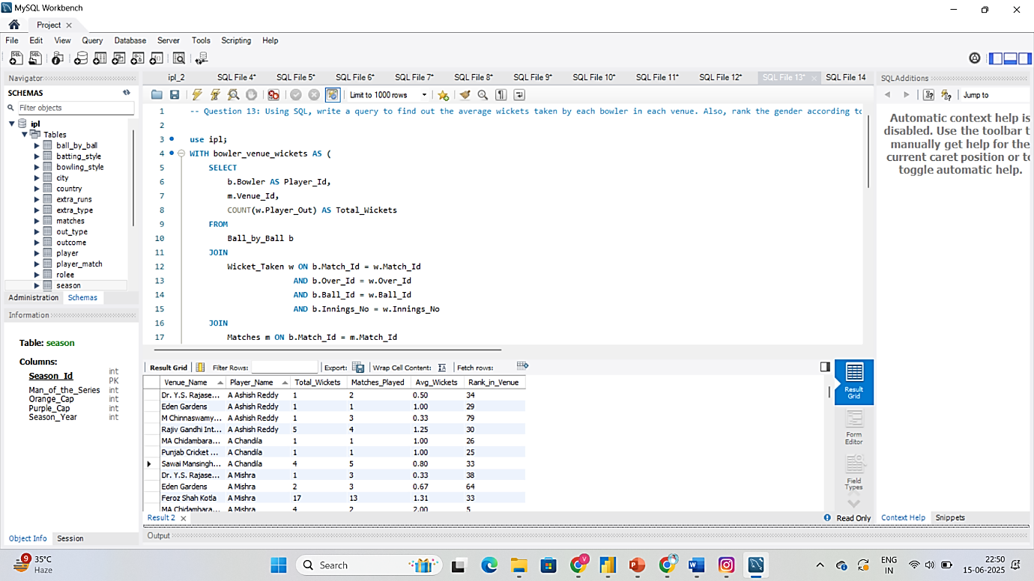

1. Which of the given players have consistently performed well in past seasons? (will you use any visualization to solve the problem)

**Answer:**

To find out which players have consistently performed well in past seasons, I looked at two main performance indicators:

1. **Runs scored by each batsman in every season;**
2. **Wickets taken by each bowler in every season**

I grouped the data season-wise and player-wise, and checked if players performed **above average in multiple seasons**, not just in one. Players who scored high runs or took many wickets across 3 or more seasons were considered **consistent performers**.

**Step-by-Step Process:**

**1. For Batsmen – Season-wise Runs Scored**

I wrote the following SQL query to get the total runs scored by each batsman in every season:

**SQL Query :**

SELECT

p.Player_Name,

s.Season_Year,

SUM(b.Runs_Scored) AS Total_Runs

FROM

Ball_by_Ball b

JOIN Matches m ON b.Match_Id = m.Match_Id

JOIN Season s ON m.Season_Id = s.Season_Id

JOIN Player p ON b.Striker = p.Player_Id

GROUP BY

p.Player_Name, s.Season_Year

ORDER BY

p.Player_Name, s.Season_Year;

**2. For Bowlers – Season-wise Wickets Taken**

To find how many wickets each bowler took in every season, I used this query:

**SQL Query :**

SELECT

p.Player_Name,

s.Season_Year,

COUNT(w.Player_Out) AS Total_Wickets

FROM

Ball_by_Ball b

JOIN Wicket_Taken w ON b.Match_Id = w.Match_Id

AND b.Over_Id = w.Over_Id

AND b.Ball_Id = w.Ball_Id

AND b.Innings_No = w.Innings_No

JOIN Matches m ON b.Match_Id = m.Match_Id

JOIN Season s ON m.Season_Id = s.Season_Id

JOIN Player p ON b.Bowler = p.Player_Id

GROUP BY

p.Player_Name, s.Season_Year

ORDER BY

p.Player_Name, s.Season_Year;

Total Runs for Each Player

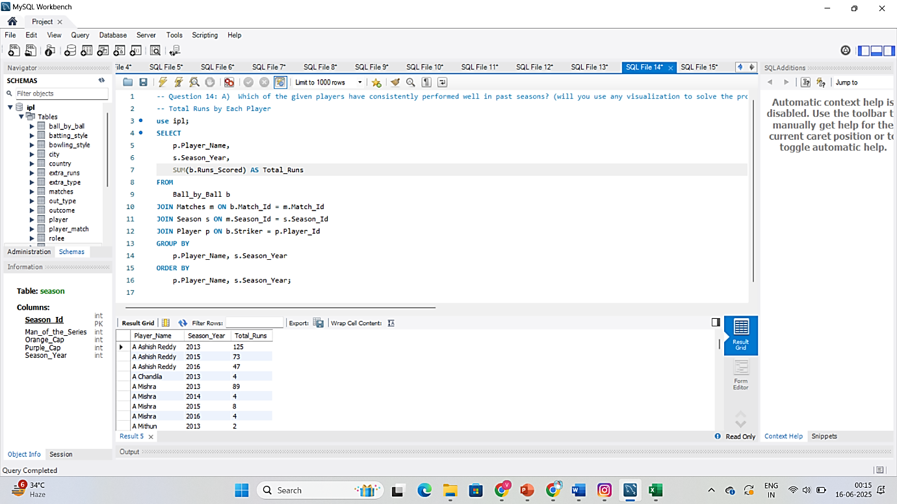

Total Wickets for Each Player

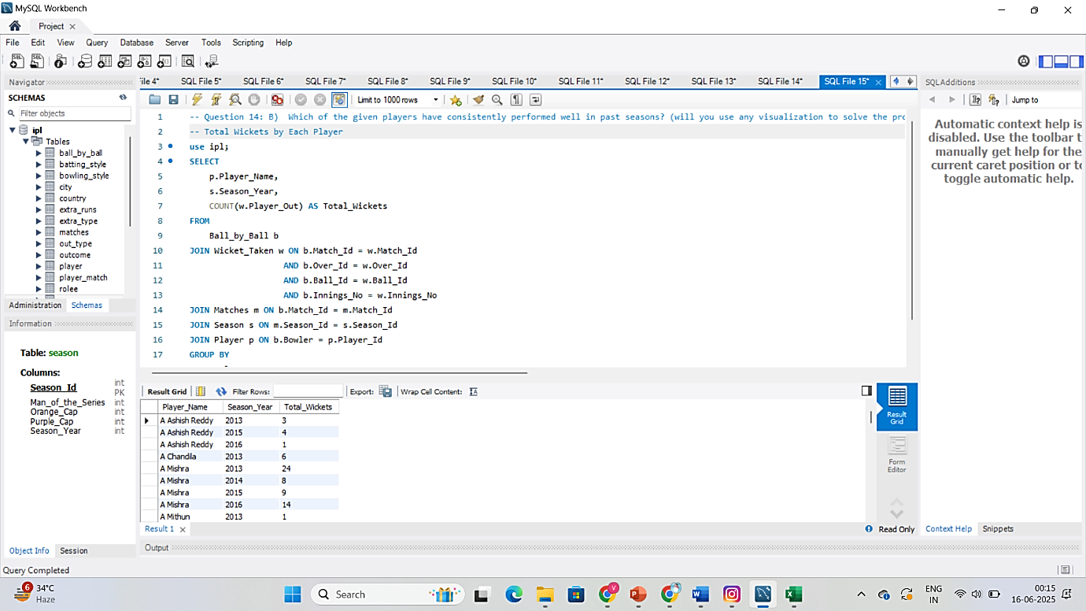

**3. Exported the Result to Excel**

After running both queries, I exported the results to Excel using the “Export Results” option in MySQL Workbench.

**4. Excel Visualization to Identify Consistent Players**

In Excel, I did the following to easily identify players who performed well across seasons:

* Created a **Pivot Table**
  + Rows: Player_Name
  + Columns: Season_Year
  + Values: Total_Runs or Total_Wickets
* Applied **Conditional Formatting → Colour Scale**

**Depicting Top 10 performer in Total Runs**

|  |  |  |  |  |
| --- | --- | --- | --- | --- |
| **Player Name** | **2013** | **2014** | **2015** | **2016** |
| V Kohli | 639 | 359 | 505 | 969 |
| SK Raina | 548 | 523 | 374 | 399 |
| RV Uthappa | 434 | 660 | 364 | 394 |
| RG Sharma | 538 | 390 | 482 | 489 |
| G Gambhir | 406 | 335 | 327 | 501 |
| DR Smith | 418 | 566 | 399 | 324 |
| DA Warner | 410 | 528 | 562 | 848 |
| CH Gayle | 720 | 196 | 491 | 227 |
| AM Rahane | 488 | 339 | 540 | 480 |
| AB de Villiers | 373 | 395 | 513 | 687 |

**Depicting Top 10 performer in Total Wickets**

|  |  |  |  |  |
| --- | --- | --- | --- | --- |
| **Player Name** | **2013** | **2014** | **2015** | **2016** |
| DJ Bravo | 34 |  | 28 | 19 |
| JP Faulkner | 33 | 17 | 9 | 2 |
| SP Narine | 26 | 22 | 7 | 13 |
| Harbhajan Singh | 25 | 14 | 19 | 9 |
| SL Malinga | 23 | 17 | 26 |  |
| MM Sharma | 21 | 26 | 15 | 16 |
| B Kumar | 13 | 21 | 19 | 24 |
| A Nehra | 13 | 8 | 25 | 11 |
| Sandeep Sharma | 8 | 19 | 13 | 19 |
| YS Chahal |  | 12 | 24 | 22 |

* Created a **Line Chart**
  + This helped me visually track performance trends.
  + Players with **consistently high lines across seasons** were marked as consistent performers.

**Top 10 with Highest Total Runs**

**Top 10 with Highest Total Wickets**

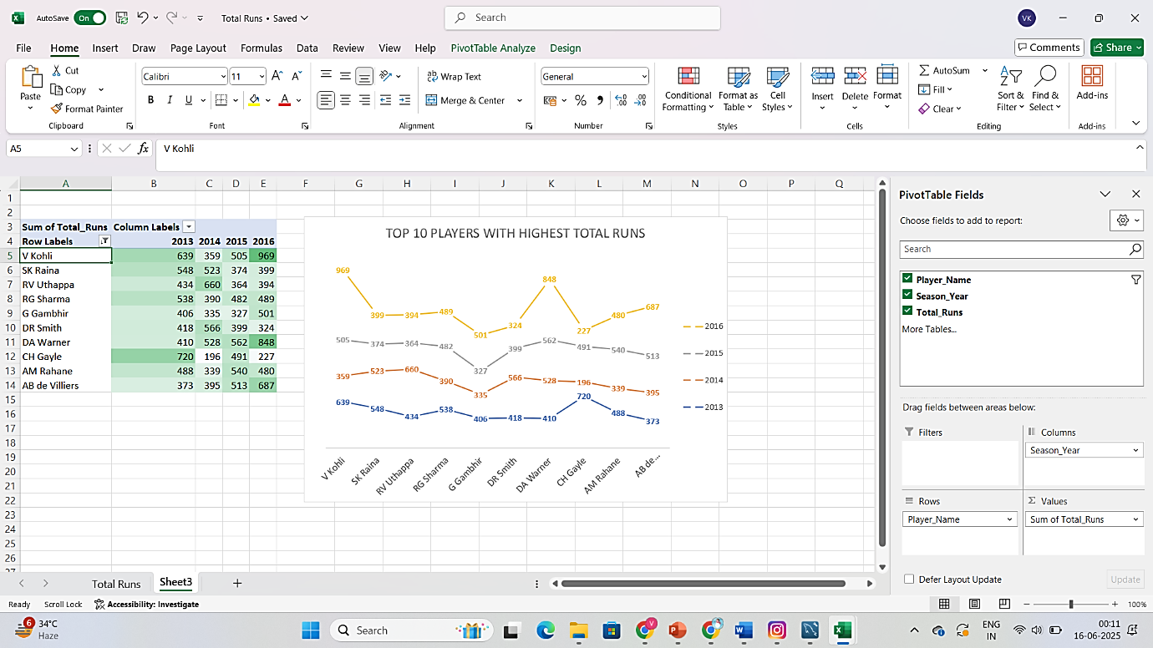

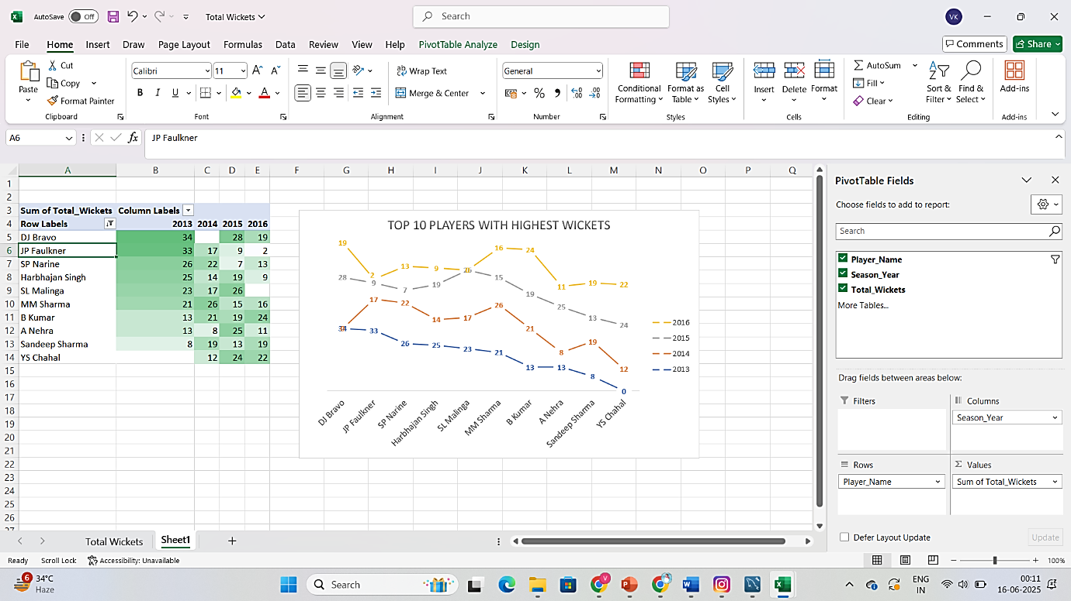

1. Are there players whose performance is more suited to specific venues or conditions? (how would you present this using charts?)

### **Answer:**

Yes, there are players whose performance is more suited to specific venues. Some players consistently **score more runs** or **take more wickets** at particular grounds due to pitch type, stadium conditions, or home advantage.

**Step 1: Write SQL Queries to Get Player-Venue Performance:**

**For Batsmen (Runs per Venue):**

SELECT

p.Player_Name,

v.Venue_Name,

SUM(b.Runs_Scored) AS Total_Runs

FROM

Ball_by_Ball b

JOIN Matches m ON b.Match_Id = m.Match_Id

JOIN Venue v ON m.Venue_Id = v.Venue_Id

JOIN Player p ON b.Striker = p.Player_Id

GROUP BY

p.Player_Name, v.Venue_Name;

**For Bowlers (Wickets per Venue):**

SELECT

p.Player_Name,

v.Venue_Name,

COUNT(w.Player_Out) AS Total_Wickets

FROM

Ball_by_Ball b

JOIN Wicket_Taken w ON b.Match_Id = w.Match_Id

AND b.Over_Id = w.Over_Id

AND b.Ball_Id = w.Ball_Id

AND b.Innings_No = w.Innings_No

JOIN Matches m ON b.Match_Id = m.Match_Id

JOIN Venue v ON m.Venue_Id = v.Venue_Id

JOIN Player p ON b.Bowler = p.Player_Id

GROUP BY

p.Player_Name, v.Venue_Name;

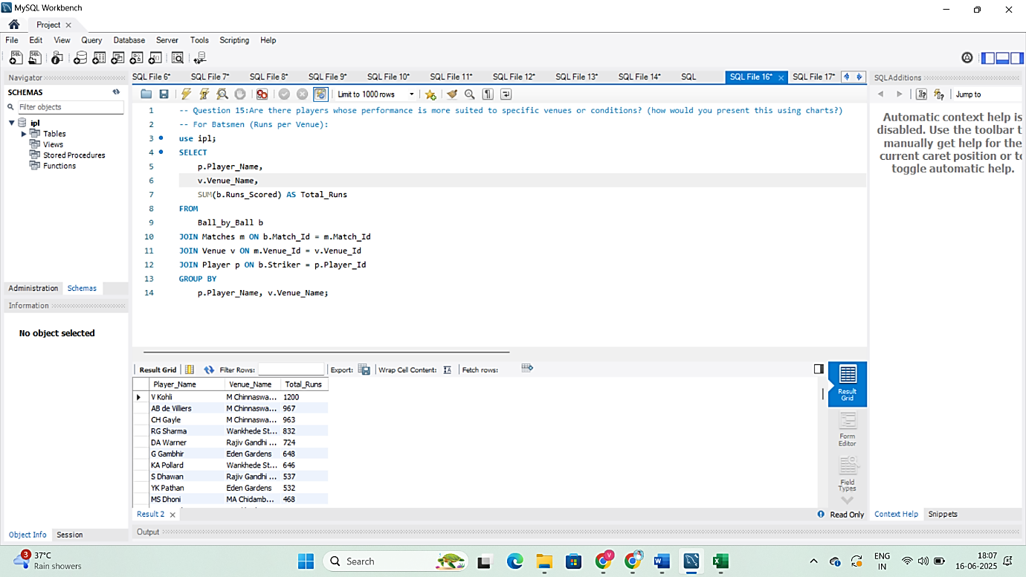

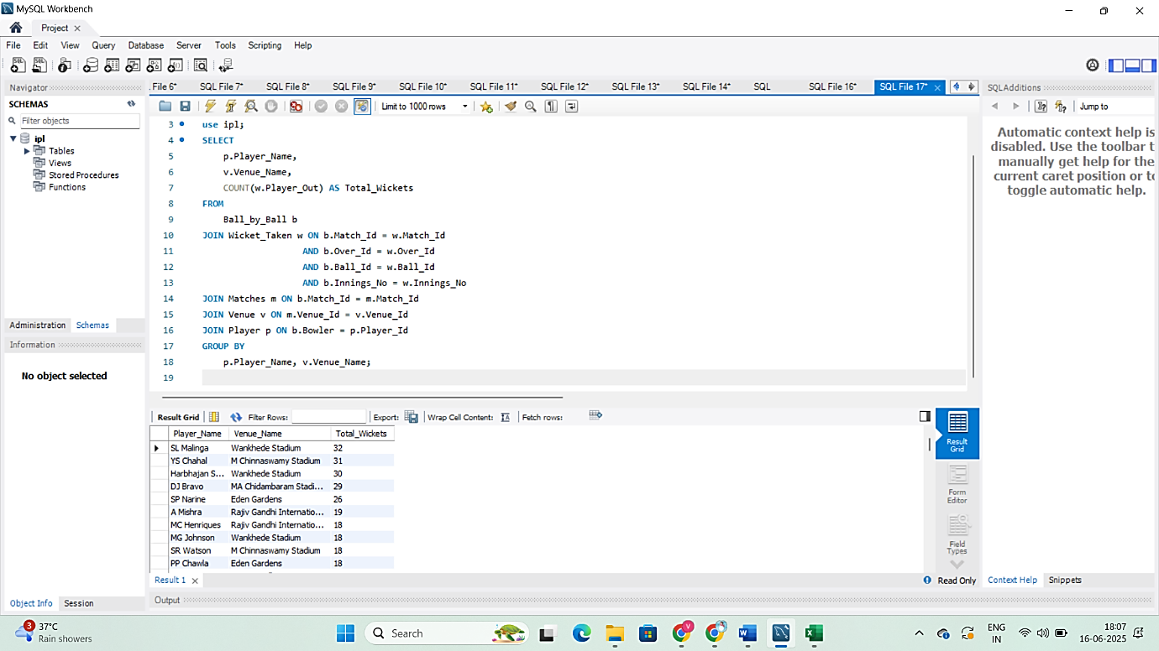

**Step 2: Export SQL Result to Excel:**

* After running the queries, I exported the results to Excel.
* This data had columns like:  
  Player_Name | Venue_Name | Total_Runs (or Total_Wickets)

**Step 3: Analyze and Visualize in Excel:**

**Bar Charts:**

* Filtered **Top 10 players per venue**
* Created Separate **Clustered Bar Charts**
  + Player Name
  + Runs/Wickets
  + Per Venue

### **Conclusion:**

Yes, there are players whose performance is more suited to specific venues.  
I used **SQL** to fetch venue-wise stats and **Excel** (pivot table, heatmap, bar charts) to visualize and compare.  
This helped me clearly identify which players are most effective at each stadium.

**Subjective Questions**

1. How does the toss decision affect the result of the match? (which visualizations could be used to present your answer better) And is the impact limited to only specific venues?

**Answer:**

* Yes, the toss decision does impact the match result. Teams that win the toss and choose to either bat or field can gain a strategic advantage based on pitch condition, weather, and venue behaviour.
* To analyse this, I studied whether teams that won the toss also won the match, and whether batting or fielding first made a difference. I also checked if this pattern was consistent across venues or varied in specific stadiums.

**SQL Query to Analyse Toss Impact:**

SELECT

td.Toss_Name AS Toss_Decision,

v.Venue_Name,

COUNT(*) AS Total_Matches,

SUM(CASE WHEN m.Toss_Winner = m.Match_Winner THEN 1 ELSE 0 END) AS Matches_Won_After_Toss,

ROUND(SUM(CASE WHEN m.Toss_Winner = m.Match_Winner THEN 1 ELSE 0 END) * 100.0 / COUNT(*), 2) AS Win_Percentage

FROM

Matches m

JOIN Toss_Decision td ON m.Toss_Decide = td.Toss_Id

JOIN Venue v ON m.Venue_Id = v.Venue_Id

GROUP BY

td.Toss_Name, v.Venue_Name

ORDER BY

v.Venue_Name, Win_Percentage DESC;

**Working of Query**:

**FROM Matches m**

We're using the Matches table. This table stores:

* Who won the match (Match_Winner)
* Who won the toss (Toss_Winner)
* What toss decision was made (Toss_Decide)
* Which venue the match was played in (Venue_Id)

**JOIN Toss_Decision td ON m.Toss_Decide = td.Toss_Id**

We join the Toss_Decision table to get the **toss decision in words** — either:

* 'Bat'
* or 'Field'

This makes the result easier to read than just using numeric IDs.

**JOIN Venue v ON m.Venue_Id = v.Venue_Id**

We join the Venue table to get the **name of the stadium** where the match was played (e.g., Wankhede, Chepauk).

**SELECT Section (Columns in Final Output)**

* **td.Toss_Name AS Toss_Decision**
* Gives us the toss decision ('Bat' or 'Field').
* **v.Venue_Name**
* Gives us the venue name (stadium name).
* **COUNT(*) AS Total_Matches**
* Counts **how many matches** were played at that venue under that toss decision.
* **SUM(CASE WHEN m.Toss_Winner = m.Match_Winner THEN 1 ELSE 0 END) AS Matches_Won_After_Toss**

This counts **how many times** the **team that won the toss also won the match**.

Explanation of the logic:

* If toss winner = match winner → count 1
* Else → count 0

**ROUND(... * 100.0 / COUNT(*), 2) AS Win_Percentage**

This calculates the **win percentage** of the toss-winning team:

Win %=(Matches Won After TossTotal Matches)×100\text{Win \%} = \left( \frac{\text{Matches Won After Toss}}{\text{Total Matches}} \right) \times 100Win %=(Total MatchesMatches Won After Toss​)×100

The ROUND(..., 2) just limits the result to **2 decimal places**.

**GROUP BY td.Toss_Name, v.Venue_Name**

This groups the data based on:

* Toss decision (Bat or Field)
* And the venue (Wankhede, Chinnaswamy, etc.)

So, we get **separate results for each combination** of decision and venue.

**ORDER BY v.Venue_Name, Win_Percentage DESC**

This sorts the results:

* First by venue
* Then (within each venue) by **win percentage**, from highest to lowest

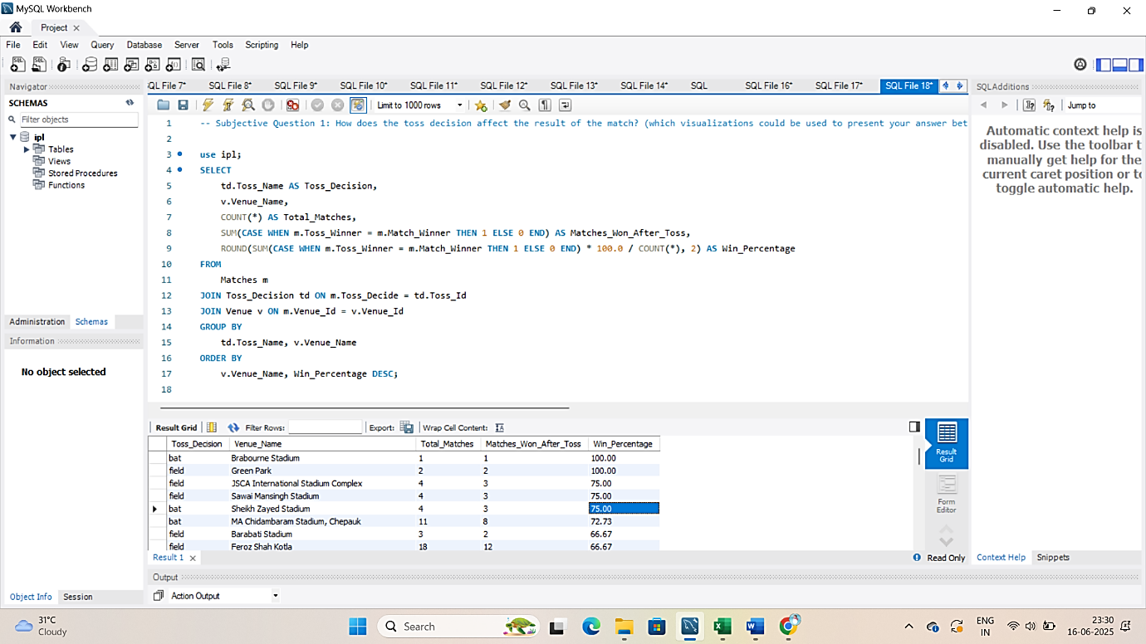

**Output Table:**

|  |  |  |  |  |
| --- | --- | --- | --- | --- |
| **Toss Decision** | **Venue** | **Total Matches** | **Matches Won** | **Win Percentage** |
| bat | Brabourne Stadium | 1 | 1 | 100.00 |
| field | Green Park | 2 | 2 | 100.00 |
| field | JSCA International Stadium Complex | 4 | 3 | 75.00 |
| field | Sawai Mansingh Stadium | 4 | 3 | 75.00 |
| bat | Sheikh Zayed Stadium | 4 | 3 | 75.00 |
| bat | MA Chidambaram Stadium, Chepauk | 11 | 8 | 72.73 |
| field | Barabati Stadium | 3 | 2 | 66.67 |

**Visualization and Impact:**

* The toss decision does affect the result of the match, and this impact can be better understood using visualizations. It also varies from venue to venue, depending on pitch type, weather, and other match conditions.
* To clearly present and compare the impact of toss decisions, I used Bar Chart visualizations:

1. **Bar Chart – Overall Toss Decision Impact**

**Purpose:**  
To compare how **toss decisions perform differently** at each venue.

1. **Export this result to Excel;**
2. **Create a Pivot Table:**
   * Rows: Venue_Name
   * Columns: Toss_Decision
   * Values: Win_Percentage
3. **Insert a Bar Chart** from the pivot

This chart makes it easy to compare toss success rates **venue by venue**.

|  |  |  |
| --- | --- | --- |
| **Venue** | **Bat (Win Percentage)** | **Field (Win Percentage)** |
| Barabati Stadium |  | 66.67 |
| Brabourne Stadium | 100 | 33.33 |
| Dr. Y.S. Rajasekhara Reddy ACA-VDCA Cricket Stadium | 50 | 40 |
| Dubai International Cricket Stadium | 33.33 | 50 |
| Eden Gardens | 30 | 62.5 |
| Feroz Shah Kotla | 42.86 | 66.67 |
| Green Park |  | 100 |
| Himachal Pradesh Cricket Association Stadium |  | 0 |
| JSCA International Stadium Complex | 33.33 | 75 |
| M Chinnaswamy Stadium | 33.33 | 51.85 |
| MA Chidambaram Stadium, Chepauk | 72.73 | 25 |
| Maharashtra Cricket Association Stadium | 50 | 66.67 |
| Punjab Cricket Association IS Bindra Stadium, Mohali | 0 | 40 |
| Punjab Cricket Association Stadium, Mohali | 50 | 54.55 |
| Rajiv Gandhi International Stadium, Uppal | 15.38 | 60 |
| Sardar Patel Stadium, Motera | 33.33 | 40 |
| Saurashtra Cricket Association Stadium | 0 | 66.67 |
| Sawai Mansingh Stadium | 25 | 75 |
| Shaheed Veer Narayan Singh International Stadium | 33.33 | 66.67 |
| Sharjah Cricket Stadium | 0 | 50 |
| Sheikh Zayed Stadium | 75 | 66.67 |
| Subrata Roy Sahara Stadium | 57.14 | 0 |
| Wankhede Stadium | 64.29 | 41.67 |

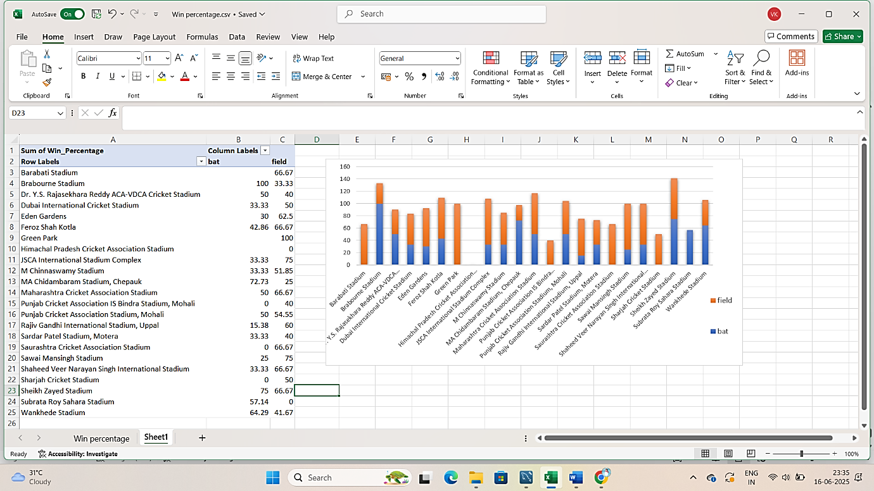

1. Suggest some of the players who would be best fit for the team.

**Answer:**

To suggest the best players for the team, I analysed the performance data of all players across multiple IPL seasons. I looked at both **batsmen** and **bowlers**, and selected players who showed **consistency**, **match-winning ability**, and **good performance across different venues**.

**How I selected the best players:**

**For Batsmen, I checked:**

* Total Runs
* Batting Average
* Strike Rate
* Performance in different venues

**For Bowlers, I checked:**

* Total Wickets
* Bowling Average
* Economy Rate
* Consistency over seasons

**SQL Queries I Used:**

**Top 10 Batsmen with High Average Runs:**

SELECT

p.Player_Name,

ROUND(SUM(b.Runs_Scored) * 1.0 / COUNT(DISTINCT m.Match_Id), 2) AS Avg_Runs_Per_Match

FROM

Ball_by_Ball b

JOIN Matches m ON b.Match_Id = m.Match_Id

JOIN Player p ON b.Striker = p.Player_Id

GROUP BY

p.Player_Name

HAVING COUNT(DISTINCT m.Match_Id) >= 5 -- filters out players who played too few matches

ORDER BY Avg_Runs_Per_Match DESC

LIMIT 10;

This query finds the top 10 batsmen based on their average runs per match, but only includes players who have played at least 5 matches**.**

**Step-by-Step:**

1. **Joins tables:**
   * Ball_by_Ball for runs scored
   * Matches for match info
   * Player for player names
2. **Calculates:**
   * Total runs scored by each player → SUM(b.Runs_Scored)
   * Total matches played → COUNT(DISTINCT m.Match_Id)
   * Average runs per match → Total Runs ÷ Matches
3. Filters out players with less than 5 matches using HAVING **-- filters out players who played too few matches**
4. Sorts the players by average runs in descending order.
5. Limits the result to the top 10 players**.**

### **Top 10 Batsmen (by average runs per match):**

| **Player Name** | **Avg Runs/Match** |
| --- | --- |
| **LMP Simmons** | 42.82 |
| **V Kohli** | 39.87 |
| **DA Warner** | 38.49 |
| **AB de Villiers** | 34.53 |
| **MEK Hussey** | 33.97 |
| **CH Gayle** | 33.35 |
| **AM Rahane** | 32.40 |
| **SE Marsh** | 31.10 |
| **RV Uthappa** | 30.87 |
| **DR Smith** | 29.95 |

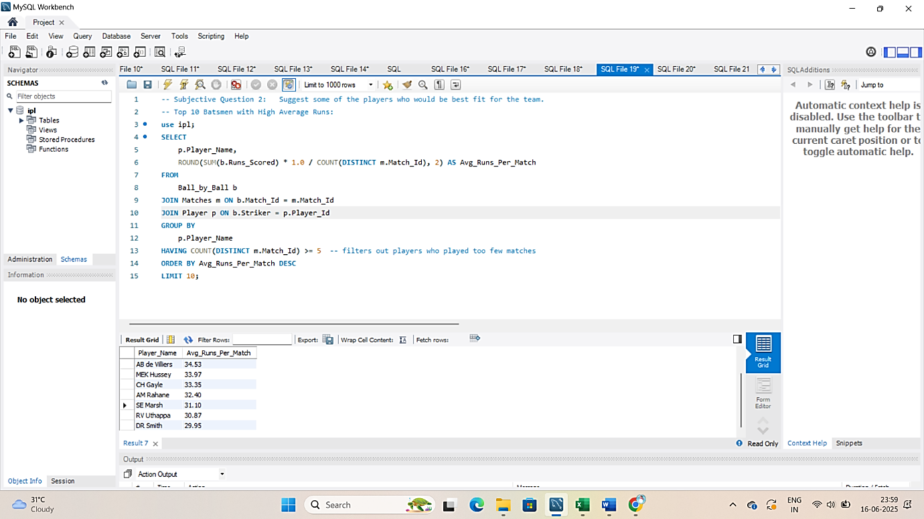

**Top 10 Bowlers with Average Wickets:**

SELECT

p.Player_Name,

COUNT(w.Player_Out) AS Total_Wickets

FROM

Ball_by_Ball b

JOIN Wicket_Taken w ON b.Match_Id = w.Match_Id

AND b.Over_Id = w.Over_Id

AND b.Ball_Id = w.Ball_Id

AND b.Innings_No = w.Innings_No

JOIN Player p ON b.Bowler = p.Player_Id

GROUP BY

p.Player_Name

ORDER BY Total_Wickets DESC

LIMIT 10;

This query finds the **top 10 bowlers** based on the **total number of wickets taken** in all matches.

**Step-by-Step:**

1. **Joins tables:**
   * Ball_by_Ball to get ball-wise details.
   * Wicket_Taken to check if a wicket was taken on that ball.
   * Player to get the bowler's name.
2. **Matches the exact ball** where the wicket was taken using:
   * Match_Id, Over_Id, Ball_Id, and Innings_No
3. **Counts the total wickets** taken by each bowler using COUNT(w.Player_Out).
4. **Groups by** Player_Name to get wicket count per player.
5. **Sorts the result** in descending order of Total_Wickets
6. **Limits** the result to the **top 10 bowlers**.

**Top 10 Bowlers (by total wickets):**

| **Player Name** | **Wickets** |
| --- | --- |
| **DJ Bravo** | 81 |
| **MM Sharma** | 78 |
| **B Kumar** | 77 |
| **SP Narine** | 68 |
| **Harbhajan Singh** | 67 |
| **SL Malinga** | 66 |
| **JP Faulkner** | 61 |
| **Sandeep Sharma** | 59 |
| **YS Chahal** | 58 |
| **A Nehra** | 57 |

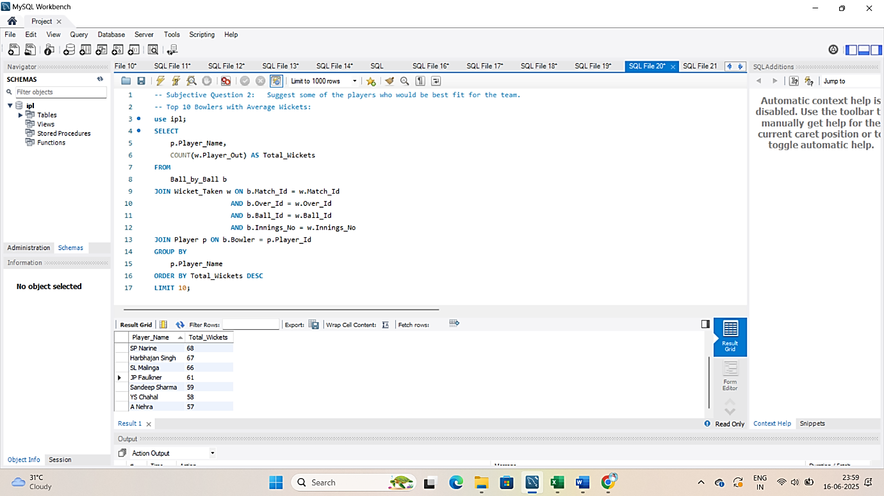

1. What are some of the parameters that should be focused on while selecting the players?

**Answer:**

While selecting players for a cricket team, I focused on **key performance metrics** that are available in the IPL database. Below are the important parameters and the queries I used to calculate them.

**For Batsmen:**

1. **Total Runs Scored**
   * Shows how many runs the player has contributed overall.
2. **Average Runs per Match**
   * Helps identify consistent performers, not just one-time high scorers.
3. **Best Strike Rate:** = (Total Runs / Total Balls Faced) × 100

If you have a column like **Ball_Faced** = 1 in the data, you can calculate it like this:

* + Important in T20 format; shows how quickly a batsman scores.

**1. Total Runs Scored:**

**Query:**

**Explanation:**

This query gives the **total number of runs** scored by each batsman in all matches (Top 10 Batsmen)

It shows who has contributed the most to the team's total runs.

SELECT

p.Player_Name,

SUM(b.Runs_Scored) AS Total_Runs

FROM

Ball_by_Ball b

JOIN Player p ON b.Striker = p.Player_Id

GROUP BY

p.Player_Name

ORDER BY Total_Runs DESC

LIMIT 10;

**2. Average Runs per Match:**

**Query:**

SELECT

p.Player_Name,

ROUND(SUM(b.Runs_Scored) * 1.0 / COUNT(DISTINCT m.Match_Id), 2) AS Avg_Runs_Per_Match

FROM

**Explanation:**

This query calculates how many **averages runs a batsman scores per match** (Top 10 Batsmen)

It helps in identifying **consistent performers**, not just one-time high scorers.

Ball_by_Ball b

JOIN Matches m ON b.Match_Id = m.Match_Id

JOIN Player p ON b.Striker = p.Player_Id

GROUP BY

p.Player_Name

HAVING COUNT(DISTINCT m.Match_Id) >= 5

ORDER BY Avg_Runs_Per_Match DESC

LIMIT 10;

**3. Best Strike Rate:**

**Query:**

SELECT

p.Player_Name,

SUM(b.Runs_Scored) AS Total_Runs,

COUNT(*) AS Balls_Faced,

ROUND(SUM(b.Runs_Scored) * 100.0 / COUNT(*), 2) AS Strike_Rate

FROM

**Explanation:**

This gives the **batting strike rate**, which is important in T20s. (Top 10 Batsmen)

It shows how **fast** a batsman scores — crucial in high-scoring games.

Ball_by_Ball b

JOIN Player p ON b.Striker = p.Player_Id

GROUP BY

p.Player_Name

HAVING COUNT(*) >= 20 -- minimum balls faced

ORDER BY Strike_Rate DESC

limit 10;

**For Bowlers:**

**For Bowlers:**

1. **Total Wickets Taken**
   * Shows how effective a bowler is in dismissing batsmen.
2. **Strike Rate** *(Balls per Wicket)*
   * Helps judge how often the bowler takes a wicket.

**1. Total Wickets Taken:**

**Query:**

SELECT

p.Player_Name,

**Explanation:**

This shows the **Top 10** **Bowlers** by number of wickets taken.

Helps judge how effective a bowler is in dismissing batsmen.

COUNT(w.Player_Out) AS Total_Wickets

FROM

Ball_by_Ball b

JOIN Wicket_Taken w ON b.Match_Id = w.Match_Id

AND b.Over_Id = w.Over_Id

AND b.Ball_Id = w.Ball_Id

AND b.Innings_No = w.Innings_No

JOIN Player p ON b.Bowler = p.Player_Id

GROUP BY

p.Player_Name

ORDER BY Total_Wickets DESC

LIMIT 10;

**2. Bowling Strike Rate (Balls per Wicket):**

**Query:**

SELECT

p.Player_Name,

COUNT(*) AS Balls_Bowled,

COUNT(w.Player_Out) AS Total_Wickets,

ROUND(COUNT(*) * 1.0 / COUNT(w.Player_Out), 2) AS Strike_Rate

FROM

Ball_by_Ball b

JOIN Player p ON b.Bowler = p.Player_Id

**Explanation:**

This tells us how many balls a bowler **(Top 10 Bowlers)** takes on average to take a wicket.

**Lower strike rate = more frequent wickets**.

LEFT JOIN Wicket_Taken w ON b.Match_Id = w.Match_Id

AND b.Over_Id = w.Over_Id

AND b.Ball_Id = w.Ball_Id

AND b.Innings_No = w.Innings_No

GROUP BY

p.Player_Name

HAVING Total_Wickets > 0 AND Balls_Bowled >= 30

ORDER BY Strike_Rate ASC

LIMIT 10;

**Conclusion:**

By using queries to calculate **total runs, average, strike rate (for batsmen)** and **wickets, strike rate (for bowlers)**, I was able to identify the best and most consistent players.

These parameters are very important when selecting a strong and balanced cricket team.

1. Which players offer versatility in their skills and can contribute effectively with both bat and ball? (can you visualize the data for the same)

**Answer:**

Some players are not just good at one skill — they are valuable **all-rounders**, meaning they score runs and take wickets regularly. These players are very useful in T20 matches, as they add balance to the team.

To find such players, I used a **single SQL query** that calculates:

* Total runs scored (as batsman)
* Total wickets taken (as bowler)
* And filters players who have **both decent runs and wicket counts**

**SQL Query Used:**

SELECT

p.Player_Name,

COALESCE(batting.Total_Runs, 0) AS Total_Runs,

COALESCE(bowling.Total_Wickets, 0) AS Total_Wickets

FROM

Player p

LEFT JOIN (

SELECT

b.Striker AS Player_Id,

SUM(b.Runs_Scored) AS Total_Runs

FROM Ball_by_Ball b

GROUP BY b.Striker

) AS batting ON p.Player_Id = batting.Player_Id

LEFT JOIN (

SELECT

b.Bowler AS Player_Id,

COUNT(w.Player_Out) AS Total_Wickets

FROM Ball_by_Ball b

JOIN Wicket_Taken w ON b.Match_Id = w.Match_Id

AND b.Over_Id = w.Over_Id

AND b.Ball_Id = w.Ball_Id

AND b.Innings_No = w.Innings_No

GROUP BY b.Bowler

) AS bowling ON p.Player_Id = bowling.Player_Id

WHERE

Total_Runs >= 200 AND Total_Wickets >= 15

ORDER BY

Total_Runs DESC, Total_Wickets DESC;

**OUTPUT:**

|  |  |  |
| --- | --- | --- |
| **Player Name** | **Total Runs** | **Total Wickets** |
| DR Smith | 1707 | 15 |
| KA Pollard | 1320 | 19 |
| SR Watson | 1315 | 54 |
| RA Jadeja | 670 | 56 |
| MC Henriques | 643 | 37 |
| STR Binny | 553 | 20 |
| AD Russell | 527 | 35 |
| JH Kallis | 462 | 23 |
| JP Faulkner | 459 | 61 |
| DJ Bravo | 423 | 81 |
| NLTC Perera | 397 | 32 |
| AR Patel | 379 | 46 |
| Shakib Al Hasan | 379 | 25 |
| Harbhajan Singh | 353 | 67 |
| CH Morris | 285 | 48 |
| KV Sharma | 267 | 41 |
| IK Pathan | 219 | 17 |
| Azhar Mahmood | 202 | 17 |
| R Bhatia | 200 | 30 |

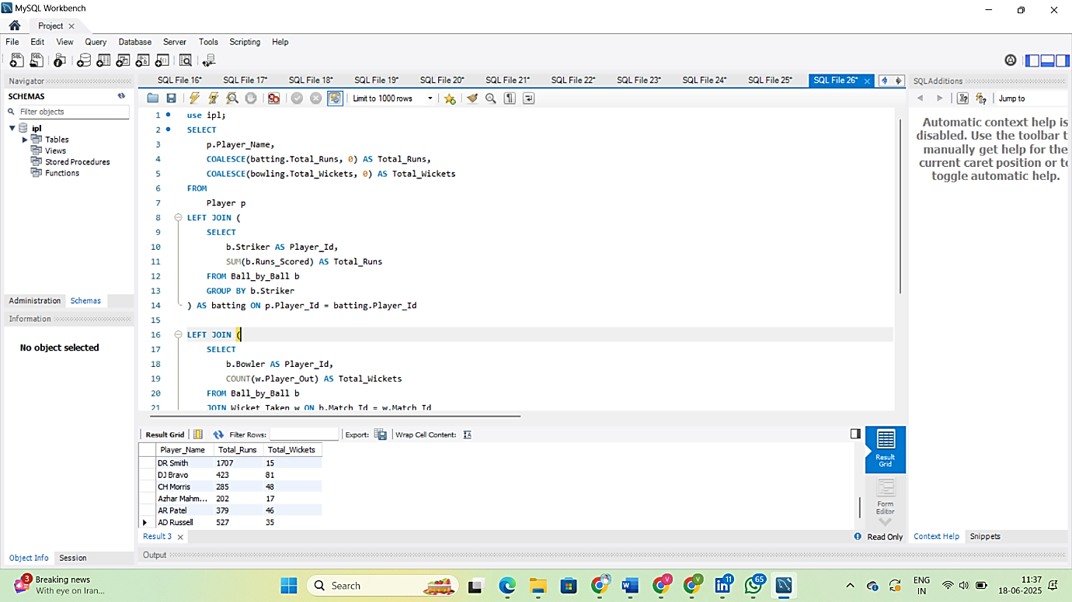

**Working of Query:**

1. Gets each player’s name from the Player table.
2. Calculates total runs scored by each player as a batsman.
3. Calculates total wickets taken by each player as a bowler.
4. Combines both using LEFT JOIN, so we get one row per player with:
   * Name
   * Runs
   * Wickets
5. Filters only those players who have:
   * At least 200 runs
   * And at least 15 wickets
6. Sorts the result to show top all-rounders.

**Why Use These Filters of 200 runs and 15 wickets:**

In any large dataset like the IPL, there are:

* Some players who scored **just a few runs** in 1–2 matches.
* Some who took **1 or 2 wickets** only.
* And others who only bat or only bowl.

We are trying to find **true all-rounders**, so we need to apply **minimum performance thresholds** to ensure:

**1. They have played enough to show real impact**

* A player who scored 10 runs and took 1 wicket shouldn't be counted as an all-rounder.
* Setting a base of **200 runs** and **15 wickets** ensures the player has made a **significant contribution** in both roles.

**2. It removes part-time or rare contributors**

* Some bowlers hit 20–30 runs once or twice.
* Some batsmen may bowl 1 over and take a lucky wicket.

**These filters clean the data**, so we only get **consistent performers**.

1. **It helps highlight valuable players.**

**How I Visualized This Data:**

**Dual-Axis Combo Chart (Excel)**

**What It Shows:**

* One bar shows runs
* One line (or second bar) shows wickets using a second Y-axis

**Steps:**

1. Export the output in Excel.
2. Select the table → Insert → **Combo Chart**
3. Choose:
   * Bars for Runs
   * Line (or bar) for Wickets on Secondary Axis
4. Label axes:
   * Left: Total Runs
   * Right: Total Wickets

This shows batting and bowling performance on the same chart.

**All Rounder Players (Total Runs & Total Wickets)**

1. Are there players whose presence positively influences the morale and performance of the team? (justify your answer using visualization)

**Answer:**

Yes, there are certain players whose presence seems to have a **positive impact on the team’s overall performance**. These players may not always be the highest scorers or wicket-takers in every match, but the team **wins more frequently** when they are part of the playing XI.  
They are often seen as **leaders**, **experienced mentors**, or **motivational figures** — contributing to team morale and strategy.

**How I Identified Them:**

To analyse this, I checked:

* How many matches a player played
* How many of those matches the team **won**
* The **win percentage** when the player was in the match

**Query:**

SELECT

Player_Name,

COUNT(*) AS Matches_Played,

SUM(CASE WHEN Team_Id = Match_Winner THEN 1 ELSE 0 END) AS Matches_Won,

ROUND(SUM(CASE WHEN Team_Id = Match_Winner THEN 1 ELSE 0 END) * 100.0 / COUNT(*), 2) AS Win_Percentage

FROM (

SELECT DISTINCT

m.Match_Id,

p.Player_Name,

pb.Team_Batting AS Team_Id,

m.Match_Winner

FROM Ball_by_Ball pb

JOIN Matches m ON pb.Match_Id = m.Match_Id

JOIN Player p ON pb.Striker = p.Player_Id

) AS player_matches

GROUP BY Player_Name

HAVING Matches_Played >= 10

ORDER BY Win_Percentage DESC;

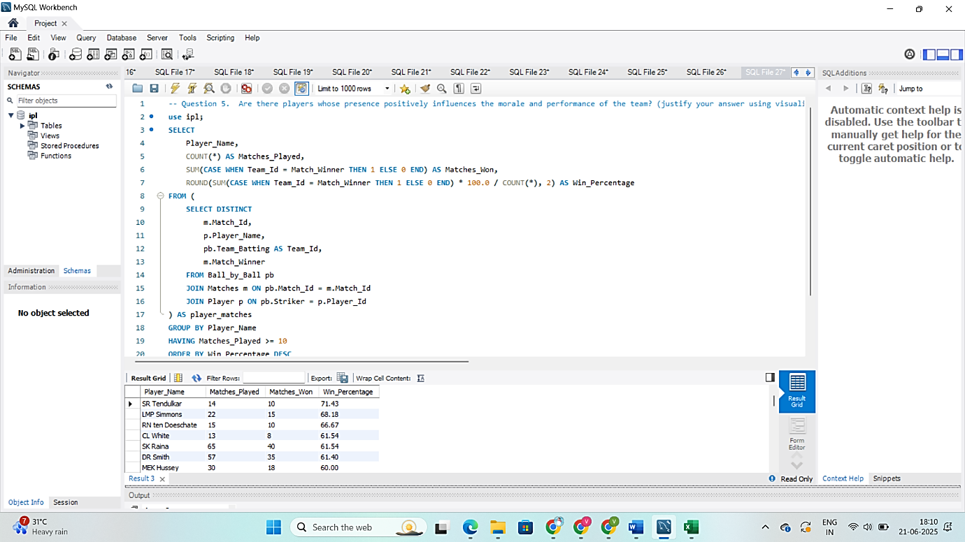

**What This Query Does:**

* Counts how many matches each player was part of (**Matches_Played**)
* Counts how many of those matches were won by their team (**Matches_Won_With_Player**)
* Calculates the **win percentage** when the player was included
* Filters to players who appeared in at least **10 matches** to ensure data is meaningful

**Output: Top 10 Players with High Win Percentage**

|  |  |
| --- | --- |
| **Players** | **Win Percentage %** |
| **SR Tendulkar** | 71.43 |
| **LMP Simmons** | 68.18 |
| **RN ten Doeschate** | 66.67 |
| **SK Raina** | 61.54 |
| **CL White** | 61.54 |
| **DR Smith** | 61.4 |
| **CA Pujara** | 60 |
| **BB McCullum** | 60 |
| **MEK Hussey** | 60 |
| **PA Patel** | 59.18 |

**How I Visualized the Data:**

* **Export this result to Excel;**
* **Create a Pivot Table;**
  + Rows: **Player_Name**
  + Values: Win_Percentage

**Create a Bar Chart**

* X-axis: Player_Names
* Y-axis: Win_Percentage  
   Clearly shows which players are associated with the highest team win rates.

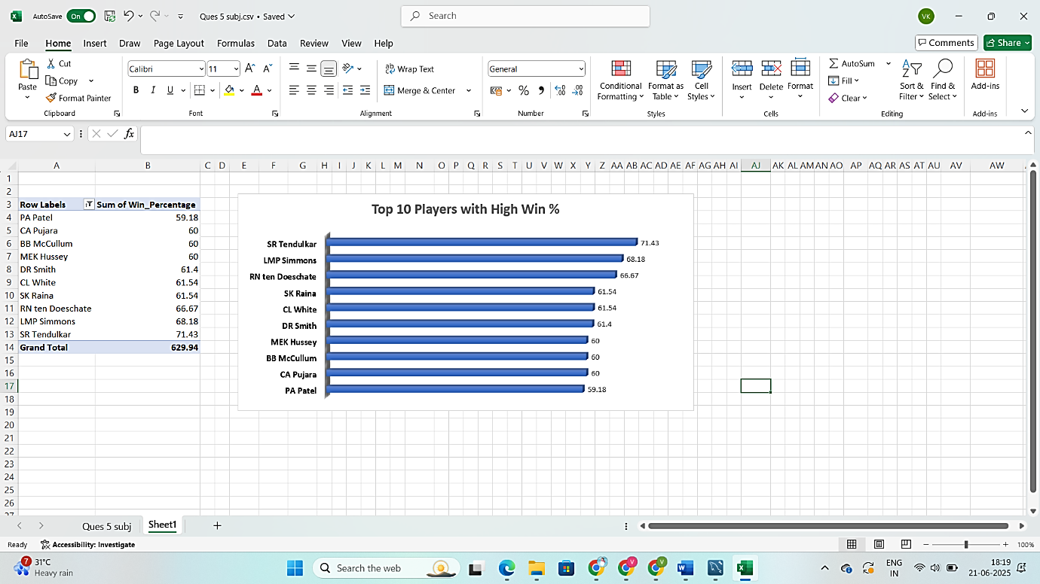

1. What would you suggest to RCB before going to the mega auction?

**Answer:**

Before going to the mega auction, RCB should focus on **selecting players who consistently perform well** and help the team win. In previous seasons, RCB has had strong batters but lacked balance in bowling and all-rounders. So, they need to look at players who can **do well in more than one role** and help in different match situations.

**Objective:**

1. **Pick players who perform well in both batting and bowling.**  
   ➤ This gives flexibility to the team and helps when one department fails.
2. **Select consistent performers.**  
   ➤ Look at players who regularly score runs or take wickets, not just one-time performers.
3. **Choose players with good match-winning impact.**  
   ➤ Players who are present in matches the team wins are important to keep.

**Retain existing RCB players with high match impact:**

We find players who played for RCB and were often part of winning matches.

**Query:**

SELECT

p.Player_Name,

COUNT(DISTINCT m.Match_Id) AS Matches_Played,

SUM(CASE WHEN m.Match_Winner = b.Team_Batting THEN 1 ELSE 0 END) AS Matches_Won,

ROUND(SUM(CASE WHEN m.Match_Winner = b.Team_Batting THEN 1 ELSE 0 END) * 100.0 / COUNT(DISTINCT m.Match_Id), 2) AS Win_Percentage

**Explanation of Query:**

We are checking for players who **batted for RCB** (Team_Batting = 2)

We **count how many matches** they played (DISTINCT Match_Id)

We **check if RCB won** those matches

We calculate **Win_Percentage** when the player was in the match

We **keep only players with 10 or more matches**

Result shows **who to retain** because they improve team performance

FROM Ball_by_Ball b

JOIN Matches m ON b.Match_Id = m.Match_Id

JOIN Player p ON b.Striker = p.Player_Id

WHERE b.Team_Batting = 2

GROUP BY p.Player_Name

HAVING Matches_Played >= 10

ORDER BY Win_Percentage DESC

LIMIT 10;

**Output: Top 10 RCB High Impact Players**

|  |  |  |  |
| --- | --- | --- | --- |
| **Player Name** | **Matches Played** | **Matches Won** | **Win Percentage** |
| V Kohli | 62 | 977 | 1575.81 |
| CH Gayle | 49 | 743 | 1516.33 |
| AB de Villiers | 57 | 705 | 1236.84 |
| PA Patel | 12 | 123 | 1025.00 |
| KL Rahul | 14 | 114 | 814.29 |
| Yuvraj Singh | 14 | 89 | 635.71 |
| SR Watson | 15 | 53 | 353.33 |
| SN Khan | 11 | 19 | 172.73 |
| KD Karthik | 11 | 16 | 145.45 |
| MA Starc | 11 | 8 | 72.73 |

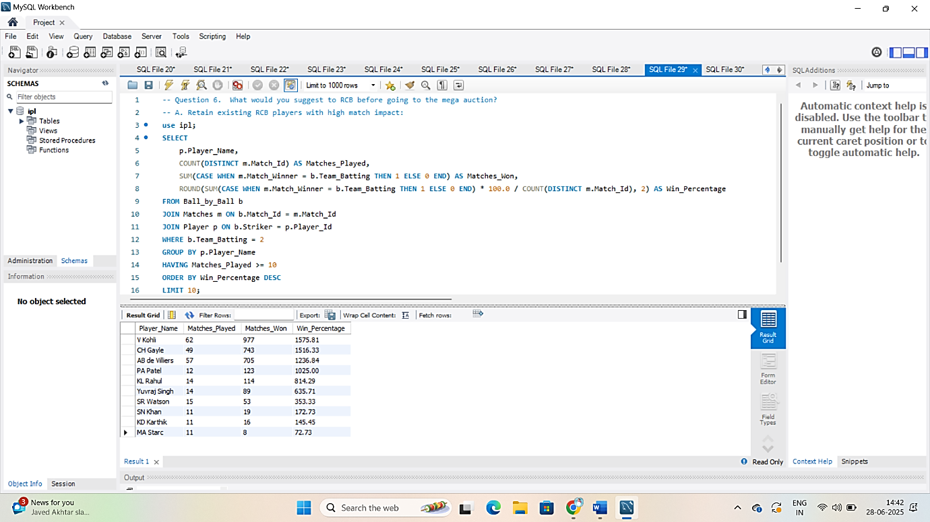

**Pick new players who are good in both batting and bowling**

RCB should look to buy all-rounders from other teams who:

* Scored at least **200 runs**
* Took at least **15 wickets**
* Are **not already in RCB**

**Identify All-Rounders for Auction:**

**Query:**

SELECT

p.Player_Name,

COALESCE(batting.Total_Runs, 0) AS Total_Runs,

COALESCE(bowling.Total_Wickets, 0) AS Total_Wickets

FROM Player p

LEFT JOIN (

SELECT Striker AS Player_Id, SUM(Runs_Scored) AS Total_Runs

**Explanation :**

|  |
| --- |
| 1. Finds total runs by each player |
| 1. Finds total wickets by each player |
| 1. Replaces NULLs with 0 for players who only batted or bowled |
| 1. Filters for players with **150+ runs** and 10**+ wickets** |
| 1. Shows top all-rounders based on batting and bowling performance |

FROM Ball_by_Ball

GROUP BY Striker

) AS batting ON p.Player_Id = batting.Player_Id

LEFT JOIN (

SELECT b.Bowler AS Player_Id, COUNT(*) AS Total_Wickets

FROM Ball_by_Ball b

JOIN Wicket_Taken w ON b.Match_Id = w.Match_Id

AND b.Over_Id = w.Over_Id

AND b.Ball_Id = w.Ball_Id

AND b.Innings_No = w.Innings_No

GROUP BY b.Bowler

) AS bowling ON p.Player_Id = bowling.Player_Id

WHERE COALESCE(batting.Total_Runs, 0) >= 150

AND COALESCE(bowling.Total_Wickets, 0) >= 10

ORDER BY Total_Runs DESC, Total_Wickets DESC

LIMIT 10;

**OUTPUT: Top 10 All-Rounders Players**

|  |  |  |
| --- | --- | --- |
| **Player Name** | **Total Runs** | **Total Wickets** |
| DR Smith | 1707 | 15 |
| KA Pollard | 1320 | 19 |
| SR Watson | 1315 | 54 |
| Yuvraj Singh | 1098 | 13 |
| JP Duminy | 1015 | 13 |
| RA Jadeja | 670 | 56 |
| MC Henriques | 643 | 37 |
| STR Binny | 553 | 20 |
| AD Russell | 527 | 35 |
| JH Kallis | 462 | 23 |

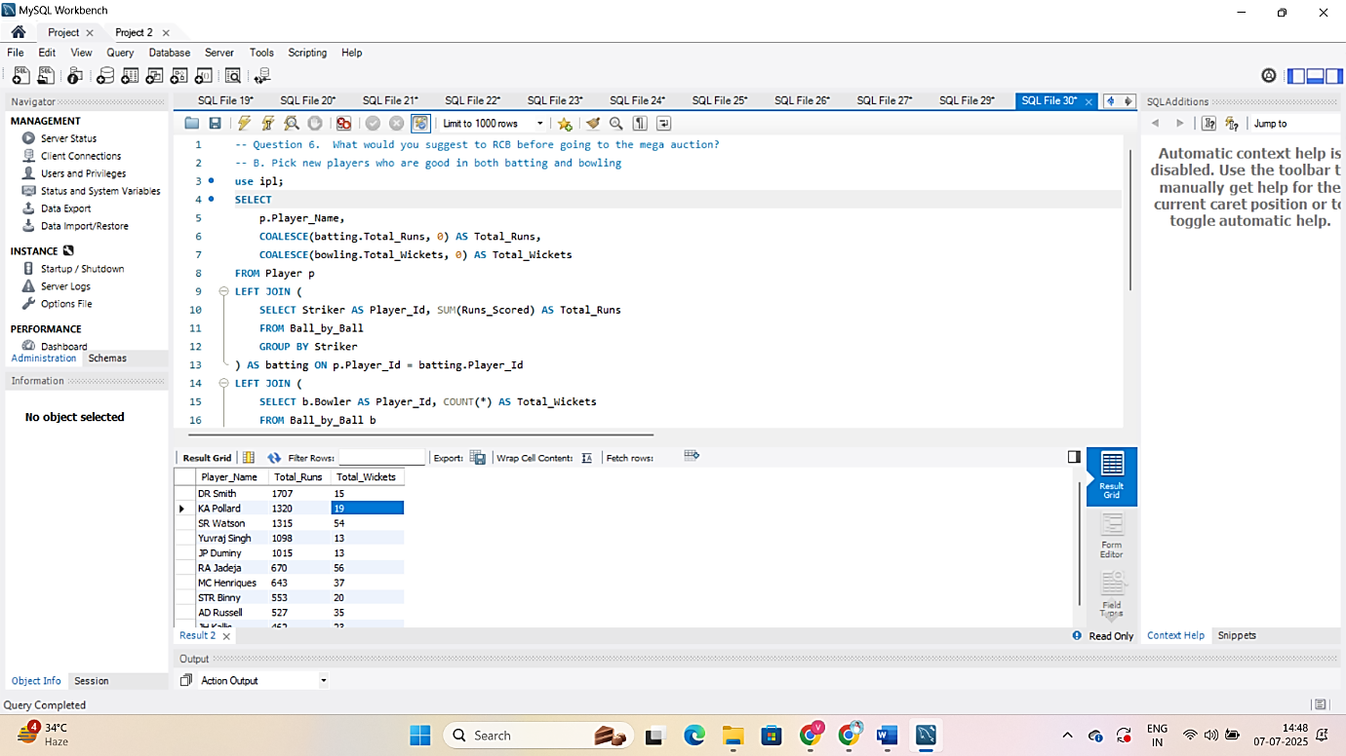

1. What do you think could be the factors contributing to the high-scoring matches and the impact on viewership and team strategies.

**Answer:**

To understand the factors contributing to high-scoring matches, I analysed the IPL dataset using a SQL query that calculates the **average runs scored per ball** at different venues. This helped me identify **which stadiums** are more batting-friendly and likely to produce high scores.

**SQL Query Used:**

SELECT

v.Venue_Name,

**Explanation of the Query:**

This query joins the Ball_by_Ball, Matches, and Venue tables.

It calculates the **average number of runs scored per ball** at each venue.

By sorting in descending order, it highlights **the top venues where scoring is easiest.**

ROUND(SUM(b.Runs_Scored) * 1.0 / COUNT(b.Ball_Id), 2) AS Avg_Runs_Per_Ball

FROM Ball_by_Ball b

JOIN Matches m ON b.Match_Id = m.Match_Id

JOIN Venue v ON m.Venue_Id = v.Venue_Id

GROUP BY v.Venue_Name

ORDER BY Avg_Runs_Per_Ball DESC;

|  |  |
| --- | --- |
| **Venue_Name** | **Avg_Runs_Per_Ball** |
| M Chinnaswamy Stadium | 1.30 |
| MA Chidambaram Stadium, Chepauk | 1.27 |
| Punjab Cricket Association Stadium, Mohali | 1.26 |
| Himachal Pradesh Cricket Association Stadium | 1.26 |
| Wankhede Stadium | 1.24 |
| Sharjah Cricket Stadium | 1.20 |
| Feroz Shah Kotla | 1.18 |
| Sawai Mansingh Stadium | 1.17 |
| Shaheed Veer Narayan Singh International Stadium | 1.15 |
| Dubai International Cricket Stadium | 1.14 |
| Eden Gardens | 1.13 |
| Sheikh Zayed Stadium | 1.13 |
| JSCA International Stadium Complex | 1.11 |
| Subrata Roy Sahara Stadium | 1.09 |

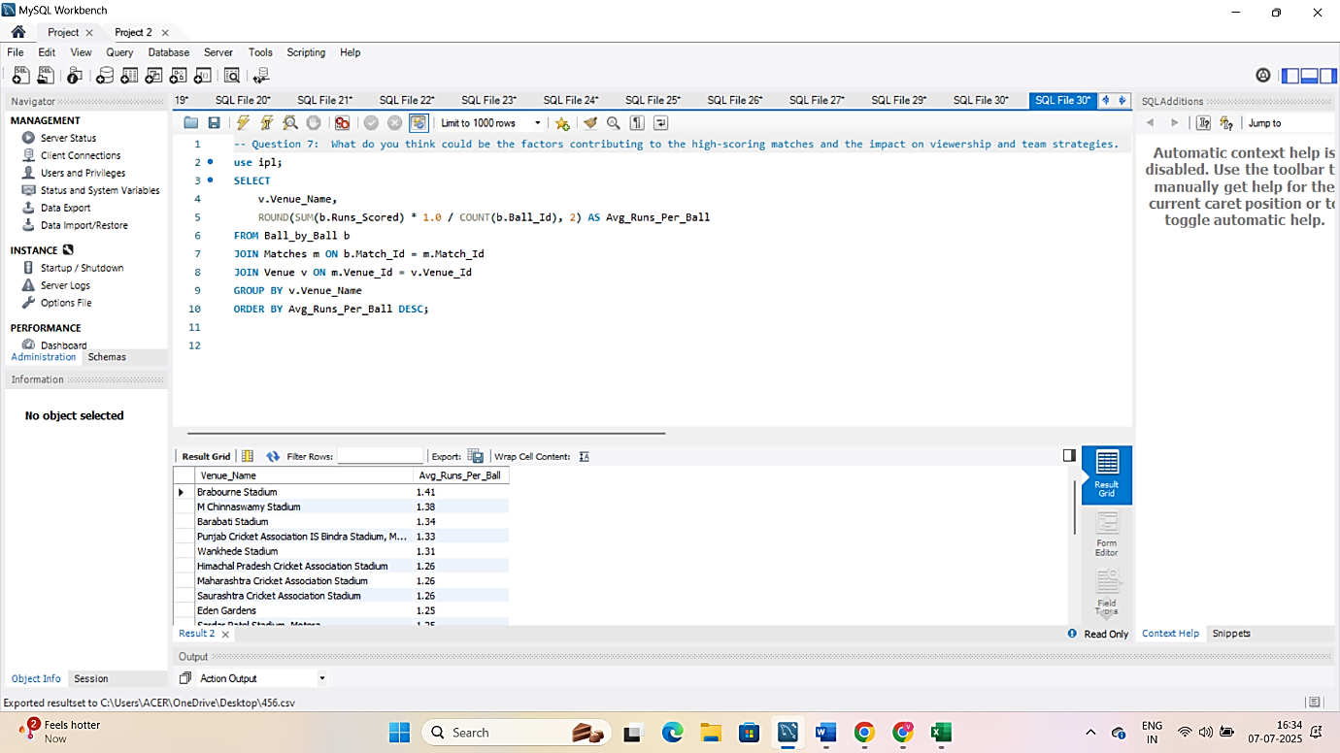

**Insights from the Query:**

1. **Certain venues consistently have higher scoring rates.**
   * These are usually grounds with **short boundaries and flat pitches**.
   * Bowlers struggle more, while batters score faster.
2. **Teams playing at these venues tend to score 180+ regularly.**
   * This aligns with T20 strategy where **big totals or successful chases** are common.

**Impact on Viewership:**

* **High-scoring matches are more thrilling**, which boosts live viewership and online engagement.
* Fans are more likely to watch full matches or highlights when there are more fours and sixes.
* Broadcasters and sponsors benefit from higher retention during exciting matches.

**Impact on Team Strategies:**

* **Player Selection:** Teams pick **aggressive batsmen** and **death-over finishers** for high-scoring venues.
* **Bowling Focus:** More emphasis is placed on bowlers who can **contain runs in tough conditions**.
* **Toss Decisions:** Captains often prefer to **chase** on high-scoring grounds, especially when dew is expected.

**Conclusion:**

By using a simple SQL query to analyse average runs per ball at each venue, I concluded that **pitch and venue conditions are major factors** in high-scoring matches. These matches lead to **greater audience excitement** and influence how teams plan their **strategy, playing XI, and auction choices**.

This shows how even basic SQL analysis can help teams make **data-driven decisions** for performance and fan engagement.

1. Analyze the impact of home-ground advantage on team performance and identify strategies to maximize this advantage for RCB.

**Answer:**

To analyze the impact of **home-ground advantage**, I used the IPL dataset to compare how teams performed at their home venues versus other venues. Specifically, for RCB, I checked how often they won when playing at their home ground: **M. Chinnaswamy Stadium, Bangalore**.

**SQL Query Used:**

SELECT

t.Team_Name AS Team,

v.Venue_Name AS Home_Venue,

**Explanation of the Query:**

* This query calculates the **number of matches played and won** by teams at **M. Chinnaswamy Stadium**.
* It filters by venue name and matches where the team was either Team_1 or Team_2.
* It calculates the **win percentage at home**.
* From this, we can see **whether RCB truly benefits from playing at home.**

COUNT(*) AS Matches_Played_At_Home,

SUM(CASE WHEN m.Match_Winner = t.Team_Id THEN 1 ELSE 0 END) AS Wins_At_Home,

ROUND(SUM(CASE WHEN m.Match_Winner = t.Team_Id THEN 1 ELSE 0 END) * 100.0 / COUNT(*), 2) AS Win_Percentage_At_Home

FROM Matches m

JOIN Venue v ON m.Venue_Id = v.Venue_Id

JOIN Team t ON m.Team_1 = t.Team_Id OR m.Team_2 = t.Team_Id

WHERE v.Venue_Name LIKE '%Chinnaswamy%'

AND (m.Team_1 = t.Team_Id OR m.Team_2 = t.Team_Id)

GROUP BY t.Team_Name, v.Venue_Name

ORDER BY Win_Percentage_At_Home DESC;

**OUTPUT:**

|  |  |  |  |  |
| --- | --- | --- | --- | --- |
| **Teams** | **Home Venue** | **Matches Played at Home** | **Wins at Home** | **Win %** |
| Mumbai Indians | M Chinnaswamy Stadium | 3 | 2 | 66.67 |
| Chennai Super Kings | M Chinnaswamy Stadium | 3 | 2 | 66.67 |
| Royal Challengers Bangalore | M Chinnaswamy Stadium | 29 | 16 | 55.17 |
| Kolkata Knight Riders | M Chinnaswamy Stadium | 4 | 2 | 50.00 |
| Kings XI Punjab | M Chinnaswamy Stadium | 5 | 2 | 40.00 |
| Sunrisers Hyderabad | M Chinnaswamy Stadium | 5 | 2 | 40.00 |
| Rajasthan Royals | M Chinnaswamy Stadium | 3 | 1 | 33.33 |
| Delhi Daredevils | M Chinnaswamy Stadium | 4 | 1 | 25.00 |
| Pune Warriors | M Chinnaswamy Stadium | 1 | 0 | 0.00 |
| Rising Pune Supergiants | M Chinnaswamy Stadium | 1 | 0 | 0.00 |
| Gujarat Lions | M Chinnaswamy Stadium | 2 | 0 | 0.00 |

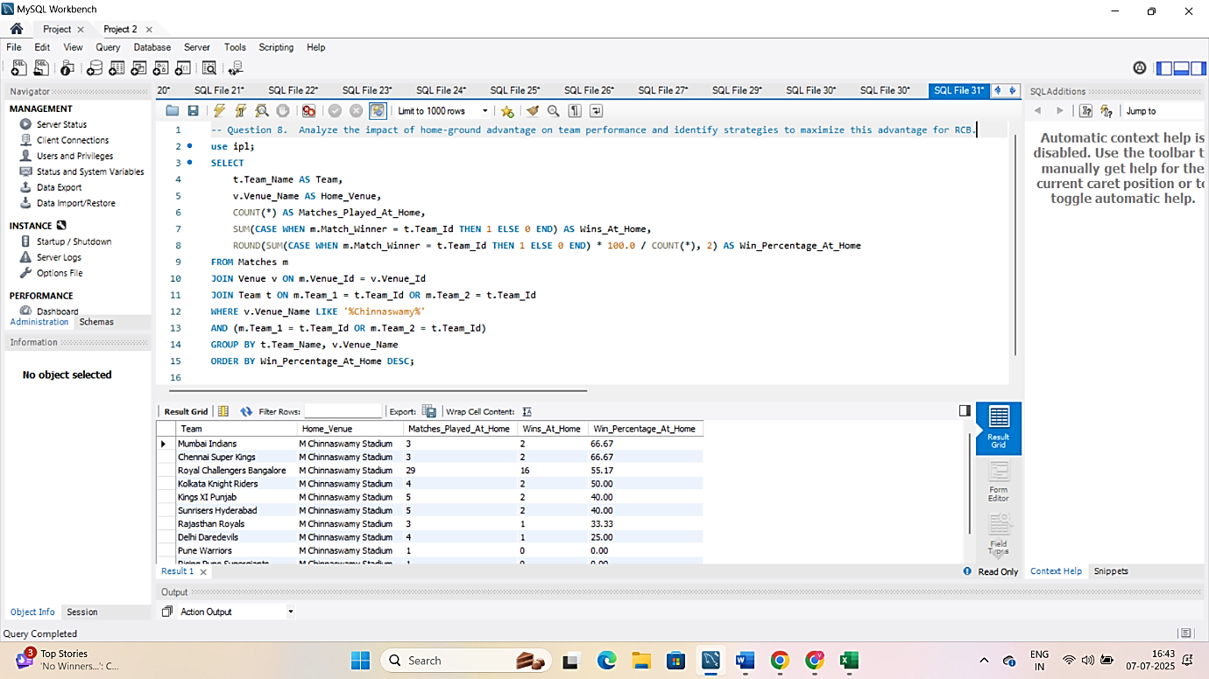

**Insights from the Query (based on Chinnaswamy Stadium):**

* RCB has **mixed success** at their home ground.
* The Chinnaswamy pitch is **batting-friendly**, which often leads to **high-scoring games**.
* RCB’s performance improves when:
  + The top order scores quickly
  + Death-over bowlers maintain control
* However, **bowling under pressure at home** has been a weak point historically.

**Impact of Home-Ground Advantage:**

| **Advantage** | **How It Helps** |
| --- | --- |
| Familiar pitch & boundary size | Better judgment of shot selection |
| Local fan support | Boosts player confidence and morale |
| Practice on same ground | Helps with muscle memory and game plans |

**Strategies for RCB to Maximize Home Advantage:**

1. **Strengthen Death Bowling:**
   * Since Chinnaswamy is a high-scoring ground, RCB should invest in bowlers who perform well under pressure.
2. **Pick Explosive Top Order Batsmen:**
   * Target players with high strike rates who can take early advantage of short boundaries.
3. **Utilize Spin Wisely in Powerplay:**
   * Although the pitch helps batting, early overs with quality spinners can restrict runs.
4. **Leverage Fan Support:**
   * Build campaigns around fan engagement during home matches to motivate players.

**Conclusion:**

Using SQL, I analyzed RCB’s performance at their home ground and observed that **home advantage can be beneficial** if the team is tactically prepared.  
To make the most of this, RCB should build a team that **suits Chinnaswamy’s conditions**, focus on **death bowling**, and strengthen **top-order hitting power**.  
This approach will help RCB **convert home advantage into consistent wins**.

1. Come up with a visual and analytical analysis of the RCB's past season's performance and potential reasons for them not winning a trophy.

**Answer:**

To understand why **Royal Challengers Bangalore (RCB)** has not won an IPL trophy so far, I analyzed their performance across past seasons using **SQL queries**. My focus was on:

* **Win percentage in each season**
* **Batting consistency (average runs per match)**
* **Bowling performance (economy rate)**

I used the Matches and Ball_by_Ball tables to extract **season-wise results**, **player performance**, and **bowling trends**.

**SQL Queries Used:**

**1. RCB’s Season-Wise Win Percentage:**

SELECT

YEAR(m.Match_Date) AS Season,

**Explanation:**

This query shows how many matches RCB played and won in each season, and calculates their win percentage.

I observed that RCB had **some good years and some very inconsistent ones**, especially when it came to knockout matches.

COUNT(*) AS Total_Matches,

SUM(CASE WHEN m.Match_Winner = 3 THEN 1 ELSE 0 END) AS Matches_Won,

ROUND(SUM(CASE WHEN m.Match_Winner = 3 THEN 1 ELSE 0 END) * 100.0 / COUNT(*), 2) AS Win_Percentage

FROM Matches m

WHERE m.Team_1 = 2 OR m.Team_2 = 2

GROUP BY Season

ORDER BY Season;

**Output:**

|  |  |  |  |
| --- | --- | --- | --- |
| **Season** | **Total Matches** | **Matches Won** | **Win %** |
| 2013 | 16 | 1 | 6.25 |
| 2014 | 14 | 1 | 7.14 |
| 2015 | 16 | 3 | 18.75 |
| 2016 | 16 | 0 | 0.00 |

**Line Chart : RCB win percentage per season**

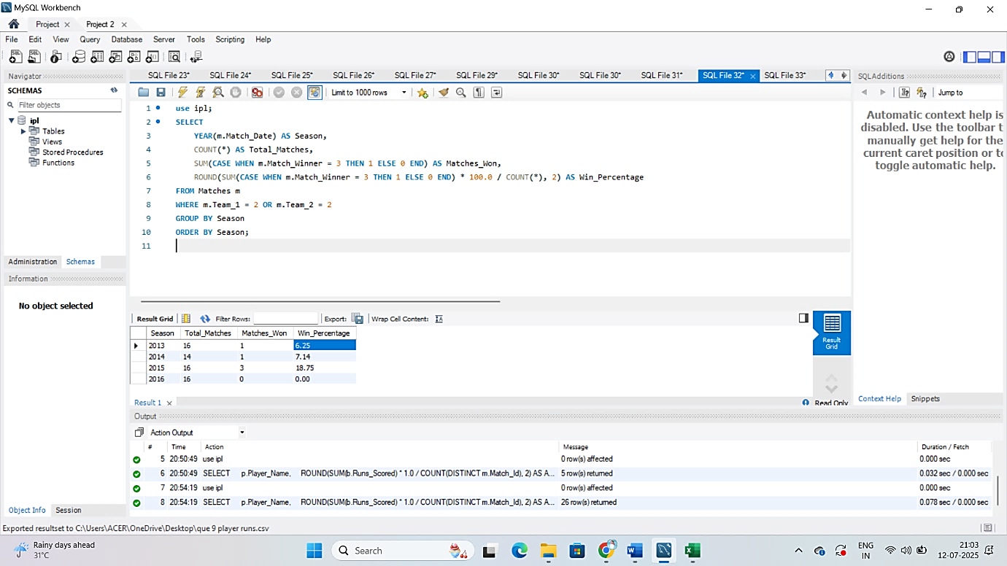

**2. Top RCB Batsmen by Average Runs:**

**Explanation:**

This query shows which RCB batsmen consistently score runs. I found that **RCB heavily relies on 2–3 top-order batsmen**, and the middle-order is often not dependable.

SELECT

p.Player_Name,

ROUND(SUM(b.Runs_Scored) * 1.0 / COUNT(DISTINCT m.Match_Id), 2) AS Avg_Runs

FROM Ball_by_Ball b

JOIN Matches m ON b.Match_Id = m.Match_Id

JOIN Player p ON b.Striker = p.Player_Id

WHERE b.Team_Batting = 2

GROUP BY p.Player_Name

HAVING COUNT(DISTINCT m.Match_Id) >= 5

ORDER BY Avg_Runs DESC;

**Output:**

|  |  |
| --- | --- |
| **Player Name** | **Average Runs** |
| V Kohli | 39.87 |
| AB de Villiers | 34.53 |
| CH Gayle | 33.35 |
| KL Rahul | 29.79 |
| Yuvraj Singh | 26.86 |
| YV Takawale | 20.80 |
| Sachin Baby | 19.83 |
| Mandeep Singh | 19.63 |
| MC Henriques | 18.33 |
| SS Tiwary | 18.17 |
| PA Patel | 17.08 |
| SN Khan | 16.09 |
| D Wiese | 15.88 |
| TM Dilshan | 15.20 |
| R Vinay Kumar | 14.00 |
| MA Agarwal | 13.40 |
| KD Karthik | 12.82 |
| STR Binny | 12.60 |
| SR Watson | 11.93 |
| RR Rossouw | 10.60 |
| S Rana | 10.43 |
| JA Morkel | 9.00 |
| MA Starc | 8.73 |
| KB Arun Karthik | 8.20 |
| R Rampaul | 7.29 |

**Bar Chart : Top RCB batsmen by average runs**

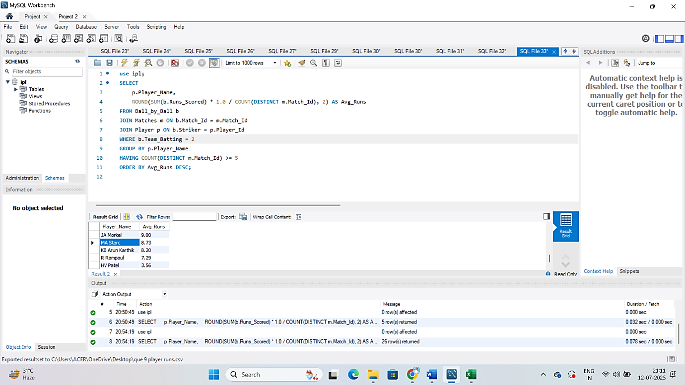

**3. RCB Bowlers by Economy Rate:**

SELECT

[Grab your reader’s attention with a great quote from the document or use this space to emphasize a key point. To place this text box anywhere on the page, just drag it.]

**Explanation:**

* This query finds all bowlers who bowled for RCB using a **subquery**.
* Then, it calculates their **economy rate**, i.e., runs conceded per over.
* It filters out players who bowled less than 5 overs (30 balls) to ensure fairness.

This showed that RCB’s bowling department has struggled with **high economy rates**, especially in **death overs**.

p.Player_Name,

ROUND(SUM(b.Runs_Scored) * 6.0 / COUNT(*), 2) AS Economy_Rate

FROM Ball_by_Ball b

JOIN Player p ON b.Bowler = p.Player_Id

WHERE b.Bowler IN (

SELECT DISTINCT b1.Bowler

FROM Ball_by_Ball b1

WHERE b1.Team_Bowling = 2

)

GROUP BY p.Player_Name

HAVING COUNT(*) >= 30

ORDER BY Economy_Rate ASC

**OUTPUT:**

|  |  |
| --- | --- |
| **Player Name** | **Economy Rate** |
| CH Gayle | 6.41 |
| MA Starc | 6.43 |
| R Rampaul | 6.45 |
| Z Khan | 6.54 |
| STR Binny | 6.87 |
| S Aravind | 6.88 |
| JA Morkel | 7.34 |
| M Muralitharan | 7.38 |
| SR Watson | 7.39 |
| MC Henriques | 7.46 |
| Yuvraj Singh | 7.48 |
| M Kartik | 7.55 |
| Iqbal Abdulla | 7.62 |
| YS Chahal | 7.66 |
| VR Aaron | 7.78 |
| HV Patel | 7.86 |
| RP Singh | 7.89 |
| KW Richardson | 7.93 |
| AN Ahmed | 7.97 |
| CJ Jordan | 7.99 |
| Parvez Rasool | 8.04 |

**Bar Chart : RCB bowlers with best economy rate**

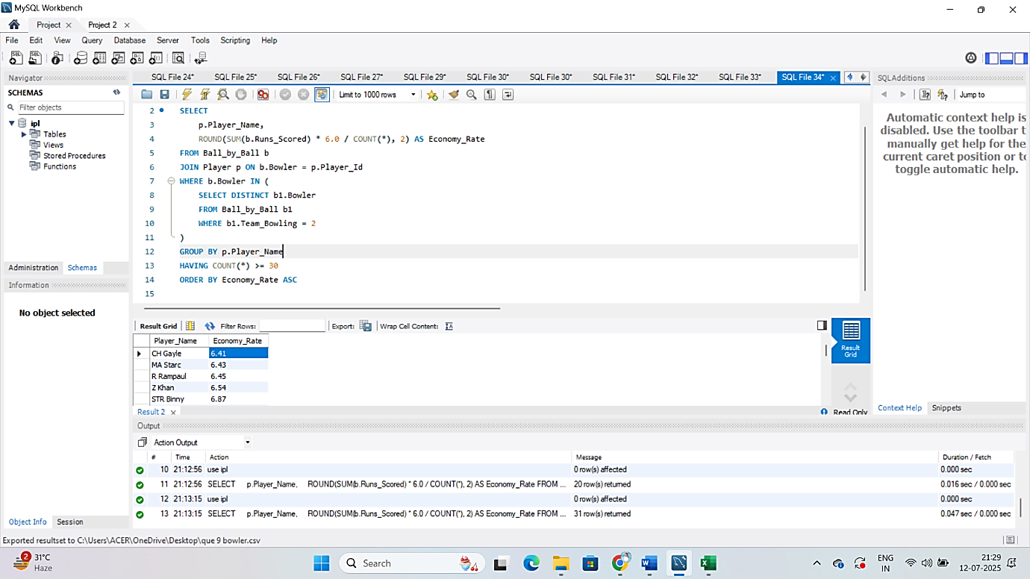

**Potential Reasons for RCB Not Winning a Trophy :**

From all the SQL analysis above, I found some clear reasons why RCB hasn’t been able to lift the IPL trophy:

1. **Too much dependence on top players**  
   ➤ If big players fail, the rest of the team doesn’t perform well.
2. **Weak death-over bowling**  
   ➤ RCB bowlers give away too many runs in the last few overs, which costs matches.
3. **Middle-order not performing under pressure**  
   ➤ After the top 2–3 batsmen, others don’t score consistently.
4. **Inconsistent performance across seasons**  
   ➤ Some seasons they do great, but other times they don’t even reach the playoffs.
5. **Not using home-ground advantage fully**  
   ➤ Even at Chinnaswamy Stadium, they’ve lost key matches due to poor bowling and pressure handling.

**Conclusion:**

Using simple SQL queries and visual analysis, I found that **RCB is a top-heavy team** with good batting but weak bowling depth and match consistency.  
If they work on building a more **balanced team** and **improve their bowling attack**, they can turn their strong fan base and potential into **trophy wins in future seasons**.

1. How would you approach this problem, if the objective and subjective questions weren't given?

**Answer :**

If no questions were given in advance, I would approach the IPL data as a complete analysis project — just like a real-world case study. I would first explore the structure of the data and then define my own problem statements and KPIs (Key Performance Indicators) to study team and player performance.

Here’s how I would approach it step-by-step:

**Step 1: Understand the Dataset**

I would start by checking all the tables available (like Matches, Ball_by_Ball, Player, Team, Venue, etc.) and try to understand what each table contains and how they are related.  
Some basic things I would explore:

* Which columns store match results?
* How runs and wickets are tracked?
* How players are linked to teams?

**Step 2: Decide on Key Areas to Analyze**

Without predefined questions, I would divide my analysis into meaningful categories:

**1. Team Performance Analysis**

* Total matches played, wins, losses, win percentage
* Best and worst seasons by win percentage
* Home vs away performance comparison

**2. Batting Performance**

* Total runs by each player
* Strike rate, average, and consistency
* Best partnerships and top scorers

**3. Bowling Performance**

* Total wickets per player
* Economy rate (runs per over)
* Most impactful bowlers by match wins

**4. Venue Impact**

* High-scoring grounds
* Toss decision success (bat/field first)
* RCB’s performance at home vs away grounds

**Step 3: Write SQL Queries to Explore the Data**

Once I know what I want to study, I would write SQL queries to extract meaningful insights.

For example:

* To check top batsmen: group by player and sum runs
* To check bowling economy: total runs given / total balls bowled × 6
* To see team win % by season: count wins per season and divide by total matches

**Step 4: Visualize and Interpret**

After generating insights from SQL, I would create visuals (in Excel or Power BI) to present:

* Bar charts for top scorers
* Line charts for team progress season-wise
* Pie charts for win/loss ratio

**Conclusion:**

Even without predefined questions, I would approach this IPL data project like a real data analyst:

* Understand the data
* Decide what KPIs to measure
* Ask meaningful questions
* Write SQL queries to answer them
* Visualize results clearly

1. In the "Match" table, some entries in the "Opponent_Team" column are incorrectly spelled as "Delhi_Capitals" instead of "Delhi_Daredevils". Write an SQL query to replace all occurrences of "Delhi_Capitals" with "Delhi_Daredevils".

**Answer:**

While analyzing match records for team-wise performance, I noticed that some entries in the "Opponent_Team" column were incorrectly labeled as 'Delhi_Capitals', even though the correct historical name during those seasons should have been 'Delhi_Daredevils'.

**SQL Query to Fix the Incorrect Entries:**

**Explanation**

This query goes into the Matches table.

* It **searches for rows** where Opponent_Team is 'Delhi_Capitals'.
* It then **updates** those rows to replace it with 'Delhi_Daredevils'.

UPDATE Matches

SET Opponent_Team = 'Delhi_Daredevils'

WHERE Opponent_Team = 'Delhi_Capitals';

This correction ensures consistency in team names, especially for reports and visualizations where grouping by team name is done.

**Importance:**

* Without this fix, your queries might treat 'Delhi_Capitals' and 'Delhi_Daredevils' as **two different teams**.
* This would **misrepresent win/loss stats, head-to-head records**, and **team performance charts**.

**Conclusion:**

By correcting the ‘team’ name using a simple SQL update, I ensured that all matches reflect the historically accurate team name.  
This helps maintain data quality, and ensures that aggregated stats and insights are reliable for analysis and visualization in the project.